
Genetic and Demographic Studies to Guide Conservation Management of Razorback Suckers in Off-Channel Habitats

2019 Final Report

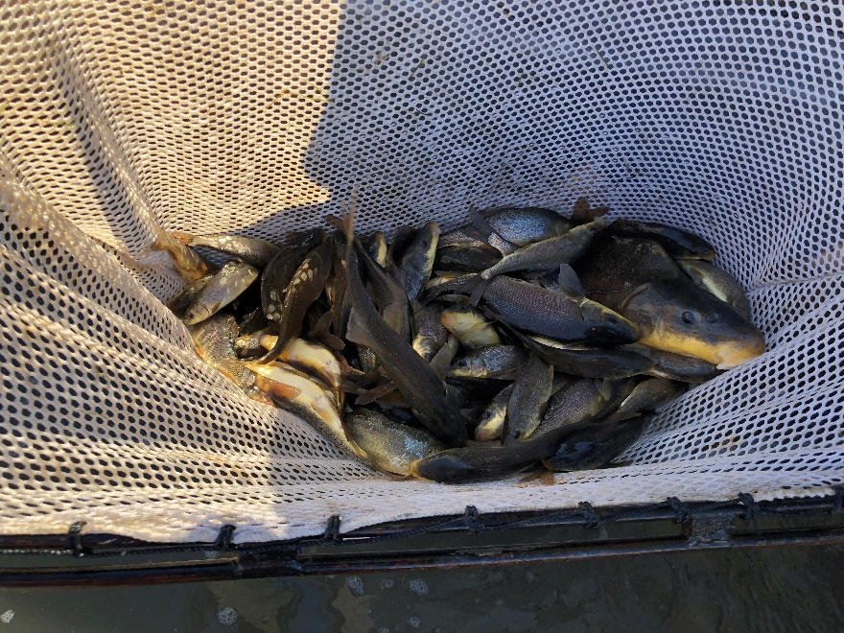

Cover photo courtesy of Jeff Lantow and the MSCP staff

Lower Colorado River Multi-Species Conservation Program
Steering Committee Members

Federal Participant Group California Participant Group

Bureau of Reclamation California Department of Fish and Wildlife
U.S. Fish and Wildlife Service City of Needles
National Park Service Coachella Valley Water District
Bureau of Land Management Colorado River Board of California
Bureau of Indian Affairs Bard Water District
Western Area Power Administration Imperial Irrigation District
Los Angeles Department of Water and Power
Palo Verde Irrigation District
Arizona Participant Group San Diego County Water Authority
Southern California Edison Company
Arizona Department of Water Resources Southern California Public Power Authority
Arizona Electric Power Cooperative, Inc. The Metropolitan Water District of Southern
Arizona Game and Fish Department California
Arizona Power Authority
Central Arizona Water Conservation District
Cibola Valley Irrigation and Drainage District Nevada Participant Group
City of Bullhead City
City of Lake Havasu City Colorado River Commission of Nevada
City of Mesa Nevada Department of Wildlife
City of Somerton Southern Nevada Water Authority
City of Yuma Colorado River Commission Power Users
Electrical District No. 3, Pinal County, Arizona Basic Water Company
Golden Shores Water Conservation District
Mohave County Water Authority
Mohave Valley Irrigation and Drainage District Native American Participant Group
Mohave Water Conservation District
North Gila Valley Irrigation and Drainage District Hualapai Tribe
Town of Fredonia Colorado River Indian Tribes
Town of Thatcher Chemehuevi Indian Tribe
Town of Wickenburg
Salt River Project Agricultural Improvement and Power District
Unit “B” Irrigation and Drainage District Conservation Participant Group
Wellton-Mohawk Irrigation and Drainage District
Yuma County Water Users’ Association Ducks Unlimited
Yuma Irrigation District Lower Colorado River RC&D Area, Inc.
Yuma Mesa Irrigation and Drainage District The Nature Conservancy

Other Interested Parties Participant Group

QuadState Local Governments Authority
Desert Wildlife Unlimited

Lower Colorado River
Multi-Species Conservation Program
Genetic and Demographic Studies to Guide Conservation Management of Razorback Suckers in Off-Channel Habitats

2019 Final Report
Prepared by:
Thomas E. Dowling¹, Brian R. Kesner², Paul C. Marsh², Kurtis R. Shollenberger², and Thomas F. Turner³

¹ Department of Biological Sciences  5047 Gullen Mall  Wayne State University  Detroit, MI 48202  313-577-3020  thomas.dowling@wayne.edu | ² Marsh & Associates, LLC  5016 South Ash Avenue  Suite 108  Tempe, AZ 85282  480-456-0801  bkesner@nativefishlab.net.  fish.dr@nativefishlab.net  kshollenberger@nativefishlab.net | ³ Museum of Southwestern Biology  MSC 03-2020  University of New Mexico  Albuquerque, NM 87131  505-277-7541  turnert@unm.edu

Dowling, T.E., B.R. Kesner, P.C. Marsh, K. R. Shollenberger, and T.F. Turner. 2019. Genetic and Demographic Studies to Guide Conservation Management of Razorback Suckers in Off-Channel Habitats, Final Report. Submitted to the Lower Colorado River Multi-Species Conservation Program, Bureau of Reclamation, Boulder City, Nevada, by Wayne State University, Detroit, Michigan; Marsh & Associates, LLC, Tempe, Arizona; and University of New Mexico, Albuquerque, New Mexico, under Agreement No. R13AC300016.

Acronyms and Abbreviations

A_{R} – allelic richness
AJ – Arizona Juvenile backwater
bp – base pair(s)
BTC – bonytail chub
DAN – Dandy backwater
DNA – deoxyribonucleic acid
F_{IS} – standard inbreeding coefficient (within populations)
GLMM – general linear mixed model
ha – hectare(s)
H_{E} – expected heterozygosity
IP – Imperial National Wildlife Refuge
m – meter(s)
µL – microliter
min – minute(s)
mm – millimeter(s)
mtDNA – mitochondrial DNA
N – sample size
ng – nanogram(s)
PCR – polymerase chain reaction
PIT – passive integrated transponder
RASU – razorback sucker (Xyrauchen texanus)
s – second(s)
SNPs – single nucleotide polymorphisms
TL – total length
USFWS – U. S. Fish and Wildlife Service
YUMA – Yuma Cove backwater

Symbols
°C degrees Celsius
> greater than
< less than
<< much less than
% percent

Contents
Page

Executive Summary 1
Introduction 3
Methods 5
Experimental Design 5
Remote Sensing 6
Statistical Analysis 11
Characterization of Genetic Variation 12
Statistical Analysis 13
Results and Discussion 14
Patterns of genetic variation in stocked adults 14
Patterns of variation in larvae/juveniles 16
Parentage assignment 16
Ephemeral ponds 19
Remote sensing 19
Genetic characterization 23
Yuma Backwater 30
Remote sensing 30
Genetic characterization 34
Imperial Ponds 38
Literature Cited 39

Tables

Table Page

Table 1.—Samples examined in this study. 7
Table 2.—PIT scanning effort (hrs of scanning) for AJ from 2010 through 2018. 9
Table 3.—PIT scanning effort (hrs of scanning) for DAN from 2010 through 2018. 9
Table 4.—PIT scanning effort (hrs of scanning) for YUMA from 2013 through 2019 (September). 10
Table 5.—PIT scanning effort (hrs of scanning) at IP from 2016 through 2019 (June). 10
Table 6.— Estimates of population genetic statistics of razorback sucker males and females stocked into AJ and DAN backwaters from the years 2010-2015 and YUMA from 2013-2015. 15
Table 7.—Estimates of population genetic statistics of razorback sucker adults (males and females pooled), larvae, and juveniles stocked into AJ and DAN backwaters from the years 2010-2015 and YUMA from 2013-2015. 17
Table 8. Results of parentage assignment for larvae and juveniles from ephemeral and permanent ponds using the programs Mykiss and Colony. 18
Table 9.—Stocking, harvest, and PIT scanning results for AJ from 2010 through 2018. 20
Table 10.—Stocking, harvest, and PIT scanning results for DAN from 2010 through 2018. 21
Table 11. —RASU contributors to genetic collections of progeny in AJ and detection via PIT scanning or harvest. 22
Table 12.—RASU contributors to genetic collections of progeny in DAN and detection via PIT scanning or harvest. 22
Table 13.—Contribution of females and males to offspring (larvae and juveniles) and the number and proportion of offspring produced by different pairs of parents. 24
Table 14. Results from regression of the number of mates for individual males and females that reproduced vs. number of offspring sampled. 25
Table 15.—Results from linear regression analyses of length and number of offspring for females and males. 26
Table 16.—Test of difference of contribution of females, males, and both combined to larvae and juveniles for each ephemeral pond sample. 29
Table 17. RASU captures from routine monitoring efforts in YUMA. 32
Table 18. Data for RASU stocked in YUMA in 2013 for which offspring (larvae or juvenile) were collected in 2014 or 2015 and were not scanned after 2013. 34

Figures

Figure Page

Figure 1.—Schematic representation of use of off-channel habitats for management of RASU (from Minckley et al. 2003). 4
Figure 2.—Scatterplots of individual length against number of offspring for samples from AJ and DAN. 27
Figure 3.—Examples of reproductive success in RASU backwater populations. Number of offspring contributed by individual females and males are indicated by open and shaded bars, respectively.
Figure 4.—PIT tagged and released RASU tracked in YUMA from February 2013 through March 2019. 31
Figure 5.—Captured and PIT tagged RASU tracked in YUMA from February 2013 through March 2019. 33
Figure 6.—Patterns of reproductive success for females and males from YUMA 2013 and 2014. 36
Figure 7.—Proportional contribution of individual females (top panel) and males (bottom panel) from YUMA 2013 for all three years (2013 – 2015).
Figure 8.—PIT tagged and released RASU tracked in three ponds at Imperial National Wildlife Refuge from December 2016 through April 2019. 38

Executive Summary

Genetic methods and remote sensing were used to examine persistence and reproductive success of stocked razorback sucker (RASU) in ephemeral and permanent ponds. Stocked adults and their progeny (larvae, juveniles) were characterized for variation at 14 microsatellite loci to assess levels of variation at various life stages, assign parentage to progeny, and quantify reproductive success of stocked adults. Levels of variation were not significantly different between the two sexes or years and locations for stocked adults; however, there was more variation in adults than their progeny. There was also typically more variation in larvae than juveniles from the same location and cohort. This result could reflect factors that affected adult contribution (e.g., early mortality, stocking of immature adults) or representation of larvae in samples (e.g., sampling effects, differential survival of larvae).

Success of parentage assignment were generally good, averaging > 86%; however, there was considerable variation in success. Two factors seemed to contribute to a lower number of parental assignments. For ephemeral ponds, lower assignment values were typically associated with small sample sizes. For the permanent pond at Yuma Cove backwater (YUMA), reduced assignment success likely reflect the inclusion of unsampled individuals, including reproductive progeny of stocked adults. Inclusion of unknown and especially related individuals in these analyses likely reduced the power of these analyses to assign parents. Inclusion of more markers will improve statistical power and should resolve this issue.

Remote sensing of stocked adults in ephemeral ponds identified loss of individuals soon after stocking. The number of individuals not scanned was highly variable among locations and years, but was typically biased towards males. These losses likely reflect mortality but could also be due to tag loss. Proportional contribution of males and females to reproduction was also variable among locations and years, ranging from 11.8% - 87.0% and 7.1% - 59.2% for females and males, respectively; however, there was no significant difference between the sexes. High levels of variation in reproductive success among ponds and years is at least partly explained by variation in early mortality. This level of variation is different from bonytail chub (BTC - Osborne et al. 2018) where most individuals contribute in every pond each year.

There was a significant relationship between the number of mates and number of offspring an individual produced, similar to BTC; however, there was no relationship between TL and reproductive success, perhaps due to the young age of these fish. Reproductive success of individual parents provided the expected relationship where a few individuals contributed the majority of progeny in each sample; however, the skew of this relationship was highly variable among years and locations. This variability likely reflects the high and variable mortality of stocked fish (especially males) early in the reproductive season for these ephemeral ponds. Mortality removes adults from the reproductive pool, reducing the number of available breeders. This is an important consideration when establishing refugial ponds as high mortality or immaturity provides fewer individuals that can contribute progeny, reducing the effective number of breeders and levels of genetic variation that can be maintained in these situations.

Remote sensing of the permanent ponds (YUMA and Imperial National Wildlife Refuge) also identified rapid loss of stocked individuals as identified in the ephemeral ponds, again biased towards males. Losses were especially high in YUMA, leading to additional stockings of 100 adults in both 2014 and 2015. Loss of individuals stocked in 2014 and 2015 was even more dramatic, affecting females as well as males. This leads to concerns over the ability to augment such ponds.

Physical sampling of YUMA identified untagged individuals that were recruits and/or holdovers that evaded capture during pond preparation. Small fish were continually captured in the pond as were larger unmarked fish, indicating that reproduction and recruitment occurred in this pond.

Genetic characterization, parentage assignment of larvae and juveniles, and patterns of reproductive success for samples from 2013 were comparable to ephemeral ponds; however, parentage assignments became more difficult in 2014 and 2015. This possibly reflects reproduction by recruits, with the existing microsatellite markers providing insufficient statistical power due to shared ancestry of stocked adults and related and uncharacterized recruits. Use of single nucleotide polymorphisms should provide additional power to address this problem.

The permanence of YUMA allowed for examination of reproductive success of specific individuals over several years, providing important perspective not available from ephemeral ponds. Reproduction was examined for adults stocked in 2013 for the period 2013 – 2015. Reproductive success of males and females were comparable in 2013, but many fewer males contributed in 2014 and 2015, likely due to loss of these individuals from the population. Most males seemed to spawn each year they were contacted. Females also tended to spawn in multiple years; however, some individuals skipped spawning in some years. This result could be real or might reflect sampling effects. While fewer individuals spawned in 2014 and 2015, most surviving individuals contributed offspring in those years, similar to results from studies of BTC. Therefore, accurate estimates of reproductive success need to be corrected for mortality.

Parentage assignments in YUMA also indicated that some RASU stocked in 2013 and lost to PIT scanning in the same year contributed to offspring in 2014 and 2015. Most of these individuals were assigned multiple offspring indicating these individuals remain in the backwater but their tags were either expelled or defective.

Introduction

The razorback sucker (Xyrauchen texanus) (hereafter RASU) is one of four species of large, long-lived, endemic fishes that were once abundant and broadly distributed throughout the Colorado River Basin (Minckley and Marsh 2009). Water development and the introduction and establishment of non-native species resulted in widespread extirpation and declines in the distribution and abundance of these and other native species beginning early in the 20th century. The impact of these factors on RASU has been profound. This catostomid fish was once abundant throughout much of the river, producing large year-classes in several newly constructed reservoirs. Unfortunately, these and other populations failed to recruit, resulting in dramatic reductions in the number and size of populations as adult fish aged and died, ultimately leading to its listing as endangered (U.S. Fish and Wildlife Service [USFWS]1991). Recruitment failure resulted from predation by nonnative fishes (Marsh and Langhorst 1988, Schooley et al. 2008, Ley et al. 2014, Ehlo et al. 2017).

As one strategy to counter this decline, a repatriation program for restoring RASU in Lake Mohave was begun in the early 1990s (reviewed in Marsh et al. 2015). The Lake Mohave program is unique in that it utilizes wild-produced larvae that are reared in protective custody and repatriated into the lake with the ultimate goal of replacing the pre-existing wild population. In an attempt to ensure accurate genetic representation of wild adults in the lake, larvae are sampled from all major spawning areas throughout the spawning period (January through April).

Molecular information indicated that there are high levels of genetic variation in RASU (Dowling et al. 1996b), with the signature indicative of an expanding population (Garrigan et al. 2002). Monitoring levels and patterns of genetic variation within and among temporal and spatial samples of larvae and repatriates indicated that the program thus far has been successful at maintaining genetic variation (Dowling et al. 2005, 2014; Carson et al. 2016). Examination of temporal variation in frequencies of different mitochondrial DNA (mtDNA) alleles allowed for estimation of the annual effective number of female breeders and the generational female effective population size (Turner et al. 2007). When this information is considered jointly with annual census data (Marsh et al. 2003, 2005, 2015), it allows for quantification of the proportion of the female population that contributes larvae each generation. This approach indicated that RASU reproductive success is consistent with other long-lived, highly fecund species and that the proportion of the population contributing larvae has increased over time (Dowling et al. 2014).

Despite best efforts, RASU numbers have declined since the species was listed as endangered. The Lake Mohave population of RASU has declined from more than 60,000 in the 1980s to fewer than 3,000 in the recent past (Marsh et al. 2003, 2005), and the most recent reported estimate of the population is approximately 3,500, with only 9 estimated wild adults (Burgad et al. 2019). Given concerns over the success of ongoing conservation programs, Minckley et al. (2003) suggested the the use of off-channel habitats to conserve this and other big river species (figure 1). In this program, native species would breed and their progeny grow in the absence of non-native fishes in isolated, protected, off-channel ponds. Panmictic adult populations would reside in the main channel and connected waters. Levels of genetic diversity would be maintained by bidirectional exchange of adults among main channel populations (e.g., Lake Mohave) and those in isolated habitats. Implementation of the plan has the potential to enhance recovery potential for this fish, as they would spend the critical part of their life history in protective custody while still being maintained in large bodies of water afforded by source populations.

Figure 1.—Schematic representation of use of off-channel habitats for management of RASU (from Minckley et al. 2003).

Demographic and genetic factors are important when considering the fate of rare taxa. RASU are iteroparous, long-lived species that are characterized by enormous reproductive capacity (mature females can produce tens of thousands of eggs per spawn). From a demographic perspective, this life history virtually guarantees a large number of offspring when rearing conditions favor recruitment. The downside from a genetic perspective is that one or a few breeding pairs could produce the majority of offspring that survive each year, and hence pass on only a small subset of the total genetic diversity available in the spawning stock, ultimately leading to increased inbreeding. Because inbreeding leads to reduced viability in RASU (Dowling et al. 1996a), it is crucial to monitor genetic diversity in progeny spawned and reared in off-channel habitats and to ascertain the number of parents contributing to offspring that are ultimately repatriated into the river. It is particularly valuable to combine a genetic monitoring approach with demographic studies (e.g., Waples et al. 2018). A combination of genetic and demographic information will permit a detailed understanding of how variation in ecological/life history features associate with spawning success and offspring viability of specific individuals. Mortality of RASU progeny is expected to be very high, especially during early life history phases (e.g., larvae and juveniles), and it is possible that certain genotypes are more likely to survive than others, particularly in the quasi-natural habitats in off-channel ponds.

Because of their lack of connectivity with other backwaters and the main river channel, isolated off-channel habitats are atypical for this species, and resulting populations will be considerably smaller than what would be expected of large, breeding aggregations in natural settings. Thus, it is critical to characterize their genetic and demographic factors in such populations to assess the potential success of this conservation strategy. RASU were used as a model system to evaluate genetic and demographic factors affecting the use of off-channel habitats as management tools for big-river fishes. The persistence of individuals within backwaters was examined using remote passive integrated transponder (PIT) scanning and assessed the importance of persistence and other factors (e.g., sex, time of spawning, and body size) on reproductive success of individuals within ponds. This is important information for management of ponds, as knowledge of persistence and reproductive success will provide necessary information about the size of ponds necessary and the frequency with which individuals need to be moved among various backwaters.

Methods

Experimental Design

Initial studies took place in two ephemeral, predator-free backwaters on Lake Mohave (Arizona Juvenile [AJ] and Dandy [DAN] backwaters) typically used for grow-out of RASU. AJ and DAN have a maximum depth of approximately 1.4 and 2.8 meters (m) at full pool (lake elevation of 202.5 m) respectively, and both are approximately 0.4 surface hectares (ha) at full pool. At the start of this experiment these ponds would dry each year as the lake level is lowered, and they had a history of producing larval RASU each year, making them ideally suited for evaluating variation in reproductive success in this species. Unfortunately, the berm in AJ breached in 2014, 2016, and 2018, and no progeny were recovered for analysis in 2016 and 2018. In addition, repair of AJ in 2016 deepened the pond, making it less likely to dry each year. This had the potential to impact this analysis in later years (discussed later).

To examine the role of genetic and demographic factors, each ephemeral backwater was stocked with 200 individuals each year (approximately 100 of each sex) in 2010-2016 and 100 individuals (approximately 50 of each sex) in 2017 and 2018. All individuals were sexed, tagged with passive integrated transponders (PIT), and fin-clipped prior to release for individual identification with remote PIT scanning and deoxyribonucleic acid (DNA) and genotyping. Attempts were made to sample larvae every two weeks and juveniles were sampled during a single event in the fall (sample sizes provided in table 1). Whole larvae and fin clips from juveniles were preserved in 95% ethanol for use in genetic analyses. Samples were routinely available from AJ but only available intermittently from DAN.

Yuma Cove backwater (hereafter YUMA) is a permanent backwater that became available for use in 2013. It is approximately 0.8 surface ha at full pool (lake elevation of 202.5 m), with a maximum depth of 3.5 m. This is deep enough to have water year around. Like AJ and DAN, YUMA was historically used for grow-out, and it has a history of larval production. Because it is a permanent pond, individuals persisted for multiple years and reproduction was also known to occur. Prior to this experiment, attempts were made to remove all RASU previously inhabiting the pond; however, it is likely that some individuals (especially juveniles and younger fish) remained in the pond.

In 2013 the initial stocking of YUMA included 200 individuals, 100 of each sex. In each of the next two years 100 additional individuals (50 males and 50 females) were stocked. All stocked individuals were PIT-tagged and fin-clipped prior to stocking to allow for DNA extraction and genotyping. Samples of larvae and juveniles included in these genetic analyses were obtained in 2013 - 2019 (table 1). No adults have been stocked since 2015; however, there has been recruitment to the population and these recruits have likely reproduced. The existence of unknown parents in YUMA without information on their sex and genotypes reduced statistical power for resolving parentage and quantifying reproductive success (Dowling et al. 2017); therefore, these samples were not analyzed here and will be utilized when the single nucleotide polymorphism markers (SNPs) are developed.

Ponds became available at the Imperial National Wildlife Refuge (IP) in 2016 and three ponds (IP1, IP3, and IP 4) were stocked with approximately 150 adult RASU of each sex in each pond. IP1, IP3, and IP4 have a maximum depth of approximately 3.1, 3.1, and 4.3 meters (m) at full pool, respectively, and are approximately 9.2, 14.2, and 8.2 surface acres, respectively at full pool. So far few larvae and juveniles have been captured from these ponds (3 larvae and 1 juvenile in 2018, 45 larvae and 163 juveniles in 2019); therefore, these populations were not genetically characterized in this report.

Remote Sensing

Three distinct types of PIT scanning units were deployed into AJ and DAN backwaters from 2015 through 2018 to monitor tagged fish, building upon results from 2010-2015 (Dowling et al. 2017). These PIT scanners were functionally
Table 1.—Samples examined in this study.
 | AJ |  |  |  | Dandy |  |  |  | Yuma
Year | females | males | larvae | juveniles | females | males | larvae | juveniles | females | males | larvae | juveniles
2010 | 129 | 71 | 210 | 11* | 100 | 100 | 207 | 41 | - | - | - | -
2011 | 100 | 100 | 306 | 202 | 100 | 100 | NA | NA | - | - | - | -
2012 | 100 | 100 | 116 | 246 | 100 | 100 | NA | 5⁺ | - | - | - | -
2013 | 102 | 98 | 243 | 44 | 100 | 100 | 65 | 275 | 100 | 100 | 180 | 125
2014 | 102 | 98 | 216 | 59 | 101 | 99 | NA | NA | 50 | 50 | 301 | NA
2015 | 100 | 100 | 606 | 0 | 99 | 101 | 63 | 25 | 50 | 50 | 456 | 122
2016 | 100⁻ | 100⁻ | NA | NA | 100 | 100 | NA | NA | 0 | 0 | 282 | 122
2017 | 51 | 50 | 298 | 341 | 50 | 50 | NA | NA | 0 | 0 | 344⁻ | NA
2018 | 50⁻ | 50⁻ | NA | NA | 50 | 50 | NA | NA | 0 | 0 | 258⁻ | 498⁻
2019 | 0^ | 0^ | NA | NA | 0^ | 0^ | NA | NA | 0 | 0 | 407⁻ | 12⁻
* = samples that were of lesser quality due to issues with the tissue preservative
NA = samples that were not available
+ = small sample not included in statistical analyses
^ = ponds not utilized in 2019

similar to those described in Kesner et al. (2008). Shore based and submersible units were used exclusively for this report. Deployment of PIT scanners was conducted at least once each spawning season (February through April), and additional supplemental scanning was conducted in other months as time permitted in AJ and DAN backwaters. Single or multiple shore-based PIT scanners have been deployed since March 2013 to continuously monitor RASU in YUMA. Additional scanning of shore-based and stand-alone submersible units were used depending on availability and season. Routine shore-based scanning was conducted to monitor RASU in Imperial Ponds, IP1, IP3, and IP4 after stocking in December 2016.

Data from PIT scanners were downloaded to a laptop computer at the end of a deployment or on a routine (monthly or quarterly) basis for the continuous units. The data were later uploaded to the lower Colorado River Remote Sensing Database through an online web form (http://www.ncreased.net) with additional header information including location, date of deployment, and PIT scanning unit type.

PIT scanning was conducted during discrete trips in AJ and DAN from 2010 to 2014, and shore based units powered by solar panel battery installations on site at AJ and DAN were used to provide seasonal (February through October) continuous scanning from 2015 through 2018 supplemented by submerible deployments. Periodic equipment failures resulted in a lack of effort or reduced effort in some months (tables 2 and 3). YUMA typically had one PIT scanning unit scanning continuously throughout the project with occasional down times due to equipment malfunction (table 4). Effort as calculated in scan-hours for continuous PIT scanner deployments extending more than a single month were assigned to the month lying at the midpoint of the deployment period (e.g. February 15 through April 15 assigned to March). Each pond at IP had two shore based units dedicated for continuous scanning with occasional down times due to equipment malfunction. PIT scanners were generally downloaded on a quarterly basis and therefore deployment time was summarized by calendar year quarters (table 5); Q1 - January through March, Q2 – April through June, Q3 – July through September, Q4 – October through December.

Table 2.—PIT scanning effort (hrs of scanning) for AJ from 2010 through 2018.
 | Month
Year | Feb | Mar | Apr | May | Jun | Jul | Aug | Sep | Oct | Total
2010 | 0 | 30 | 93 | 0 | 0 | 0 | 0 | 0 | 0 | 124
2011 | 181 | 70 | 15 | 32 | 0 | 0 | 0 | 0 | 0 | 299
2012 | 0 | 14 | 0 | 0 | 0 | 0 | 0 | 0 | 0 | 14
2013 | 0 | 47 | 42 | 0 | 0 | 0 | 0 | 453 | 0 | 542
2014 | 0 | 194 | 86 | 0 | 0 | 0 | 48 | 148 | 0 | 476
2015 | 0 | 0 | 180 | 769 | 400 | 550 | 939 | 920 | 338 | 4096
2016 | 267 | 814 | 466 | 216 | 27 | 994 | 671 | 1007 | 0 | 4462
2017 | 327 | 771 | 576 | 793 | 485 | 793 | 0 | 220 | 0 | 3966
2018* | 6 | 0 | 779 | 38 | 55 | - | - | - | - | 878
Sums | 782 | 1941 | 2237 | 1849 | 967 | 2336 | 1658 | 2749 | 338 | 14857
* Flooding in June 2018 destroyed the berm at AJ allowing fish in the backwater to escape. PIT scanning was ineffective afterwards.

Table 3.—PIT scanning effort (hrs of scanning) for DAN from 2010 through 2018.
 | Month
Year | Feb | Mar | Apr | May | Jun | Jul | Aug | Sep | Total
2010 | 0 | 87 | 56 | 0 | 1* | 43 | 0 | 0 | 187
2011 | 40 | 53 | 42 | 29 | 0 | 0 | 0 | 0 | 164
2012 | 0 | 42 | 0 | 0 | 0 | 0 | 0 | 0 | 42
2013 | 0 | 75 | 28 | 0 | 0 | 0 | 0 | 450 | 553
2014 | 0 | 205 | 148 | 0 | 0 | 0 | 81 | 145 | 580
2015 | 0 | 0 | 146* | 582 | 0 | 140 | 473 | 255 | 1596
2016 | 169 | 598 | 714 | 393* | 648 | 837 | 656 | 910 | 4924
2017 | 619 | 614 | 646 | 713 | 629 | 675 | 360 | 632 | 4887
2018 | 587 | 265 | 227* | 627 | 429 | 506 | 353 | 541 | 3536
Sums | 1415 | 1938 | 2007 | 2344 | 1706 | 2200 | 1924 | 2933 | 16467
* Deployment time was reduced due to equipment malfunction.

Table 4.—PIT scanning effort (hrs of scanning) for YUMA from 2013 through 2019 (September).
 | Month
Year | Jan | Feb | Mar | Apr | May | Jun | Jul | Aug | Sep | Oct | Nov | Dec | Total
2013 | 0 | 818 | 715 | 862 | 0 | 564 | 0 | 0 | 378 | 0 | 258 | 0 | 3594
2014 | 344 | 34 | 636 | 618 | 154 | 46 | 0 | 442 | 515 | 422 | 369 | 294 | 3875
2015 | 756 | 974 | 526 | 782 | 868 | 834 | 847 | 839 | 554 | 812 | 987 | 455 | 9234
2016 | 656 | 607 | 342 | 1661 | 1732 | 1296 | 1724 | 1338 | 1709 | 729 | 408 | 1108 | 13312
2017 | 1567 | 1541 | 1257 | 1709 | 717 | 2160 | 2108 | 965 | 2119 | 0 | 1167 | 1125 | 16435
2018 | 1393 | 624 | 679 | 784 | 2781 | 1008 | 2069 | 1900 | 2019 | 2424 | 2021 | 2086 | 19786
2019 | 2119 | 1240 | 670 | 818 | 1514 | 948 | 964 | 536 | 695 | 0 | 0 | 0 | 9504
Sums |  | 5837 | 4825 | 7234 | 7766 | 6855 | 7711 | 6021 | 7989 | 4387 | 5210 | 5069 | 75741

Table 5.—PIT scanning effort (hrs of scanning) at IP from 2016 through 2019 (June).
Scanning was generally downloaded on a quarterly basis: Q1 – January through March; Q2 – April through June; Q3 – July through September; Q4 – October through December.
 | 2016 | 2017 |  |  |  | 2018 |  |  |  | 2019
Pond | Q4 | Q1 | Q2 | Q3 | Q4 | Q1 | Q2 | Q3 | Q4 | Q1 | Q2 | Total
1 | 1101 | 6485 | 2179 | 4404 | 4416 | 4320 | 4368 | 3637 | 3421 | 2353 | 2390 | 39074
2 | 0 | 171 | 3859 | 5997 | 6623 | 6480 | 6552 | 5960 | 2696 | 4708 | 4218 | 47263
3 | 499 | 2883 | 3195 | 2207 | 4416 | 4320 | 4368 | 5844 | 2602 | 3984 | 4746 | 39065
4 | 782 | 3919 | 4357 | 4414 | 4395 | 4295 | 4341 | 4407 | 1348 | 4707 | 4747 | 41712
5 | 0 | 306 | 4009 | 3462 | 6552 | 6447 | 5425 | 5252 | 3898 | 6225 | 4260 | 45836
6 | 0 | 284 | 4361 | 5668 | 6621 | 6475 | 6550 | 6616 | 4042 | 6222 | 7117 | 53956
Sums | 2381 | 14047 | 21960 | 26153 | 33023 | 32337 | 31604 | 31717 | 18006 | 28199 | 27478 | 266907

Stocking, harvest, and sampling data from AJ, DAN, YUMA, and IP were recorded by Reclamation, ASU, Wayne State, or Marsh & Associates personnel on paper datasheets and were entered into the Lower Colorado Native Fish Database.

Statistical Analysis

AJ and DAN have been used as experimental ponds since 2010. These ponds are ephemeral, drying out each autumn/winter due to dam operations; therefore, they provide single point estimates of important demographic parameters based on stocking and harvest data; growth, survival, and recruitment size. Any recruits in these ponds were removed prior to drying and stocked elsewhere. For the non-ephemeral ponds, YUMA and IP, RASU captured in the ponds without tags were injected with a PIT tag prior to release back into their pond of capture. In addition to tagging, fish were measured for total length (TL), sexed, and examined for general health and condition. The origin of RASU in YUMA and IP was tracked by labeling each fish as repatriates, fish that were stocked with PIT tags, or as “unknown,” fish captured and tagged during pond sampling. Unknown fish included newly recruited fish as well as repatriates that lost their PIT tags. Although there were clear cases of backwater recruits among backwater tagged fish, any size cutoff between recruits and repatriates with lost tags would be arbitrary. An exception to this distinction was used for eight fish greater than 400 millimeters (mm) TL captured in 2013 (YUMA). These fish were assumed to be repatriates that lost tags (Minckley 1983, McCarthy and Minckley 1987).

Survival was calculated for each sex in AJ and DAN based on paired stocking and harvest data, defined as total number of PIT tagged fish harvested with a stocking record divided by the total number of PIT tagged fish stocked (% harvested). This value was calculated for each sex as determined at the time of stocking. PIT scanning data for AJ and DAN were summarized by month as the number of unique PIT tags contacted per month. RASU spawning activity in Lake Mohave usually peaks before March 15. Therefore, the percentage of fish harvested that were PIT scanned after March 15 was calculated as a measurement of PIT scanning effectiveness: i.e. the percentage of the RASU spawning population that PIT scanning contacted. In addition, the parental assignments of offspring (larvae and juveniles) were compared to harvest and PIT scanning data to calculate the percentage of adult RASU that contributed to the offspring but were not harvested or PIT scanned during the entire study year. This was calculated to determine if the original stocking number or the total number of RASU harvested or scanned was a better estimate of the number of contributors.

For RASU in YUMA and IP the minimum population size through time was determined from nearly continuous PIT scanning data. Individual fish were known to be alive and considered as part of the minimum population size if they were scanned between a given date and the last day of scanning for this report, September 30, 2018. These minimum population size values were calculated each day from the stocking date through May 31, 2019. A five-month gap was used between the last date reporting a minimum population size (May 1, 2019) and the last day of scanning (September 30, 2019) to reduce the likelihood that a fish was alive but was missed by PIT scanners. This simple and intuitive statistic was used instead of mark-recapture population estimates because the technique provides specific information on the individual fish that were known to be alive on a given date as opposed to a population estimate which only provides a single point estimate on the number of individuals alive. Individuals contacted by PIT scanning were directly compared to parental assignments of larvae and juveniles to identify contributors in 2014 and 2015 from the 2013 stocking that were not PIT scanned in 2014 or 2015 Sex specific and backwater recruit values of minimum population size were calculated in Microsoft Excel. Due to a lack of observed recruitment in IP at the time this report was drafted, all data presented in this report are for individual RASU stocked in December 2016 (no backwater recruits).

Characterization of Genetic Variation

DNA was extracted from larvae and fin clips using a standard phenol-chloroform extraction protocol (Tibbets and Dowling 1996). The quantity and quality of DNA were assessed using a NanoDrop ND-1000 Spectrophotometer (V3.0.1). Genetic variation among samples was assessed using 14 dinucleotide microsatellite loci developed from a library for RASU (Turner et al. 2009; Dowling et al. 2014). Microsatellite fragments were amplified in the following multiplexed polymerase chain reactions (PCRs) using an Eppendorf Mastercycler thermal cycler: multiplex 1: Xte1, Xte7, Xte20; multiplex 2: Xte2, Xte10, Xte16, multiplex 3: Xte11, Xte12, Xte19, Xte24; and multiplex 4: Xte8, Xte17, Xte18, Xte25. Multiplexed amplifications were completed in 5-microliter (µL) reactions consisting of 2.5 µL of Qiagen Master Mix (Taq DNA Polymerase, PCR Buffer, MgCl₂, and dNTPs), 0.01 to 0.45 µL of each primer (varies from 0.2 micromolar to 9 micromolars), 1 µL of water, and 0.5 µL of genomic DNA (100–1,000 nanograms [ng]). Multiplex 1 was amplified using a profile that followed a traditional PCR format. The first step was a denaturation of 15 minutes (min) at 95 degrees Celsius (°C), followed by 25 cycles of 94 °C for 30 seconds (s) for denaturation, an annealing step of 53 °C for 90 s, and 72 °C for 1 min, and the amplification was completed with a single step at 72 °C for 10 min. Multiplex 2, 3, and 4 were amplified using a profile that followed a touchdown format: initial denaturation of 15 min at 95 °C; 25 cycles of 94 °C for 30 s, annealing at 65 °C for 1.5 min, and 72 °C for 1 min. Annealing temperature decreased by 1 °C in each of the first 15 cycles and remained at 50 °C for the remaining 10 cycles. Amplification was completed with a single step at 72 °C for 10 min.

A microsatellite fragment analysis was completed using a Li-Cor 4300 DNA Analyzer. Five lanes of size standard (50–350 base pairs [bp] from Li-Cor) were incorporated on each run, and each gel was scored using the computer software Saga (version 3.3). The software determines the size of each fragment using the size standards and assigns a genotype to each individual. Consistency of allele assignment across gels was obtained by manual comparison of results from multiple gels simultaneously.

Statistical Analysis

Population genetics parameters (allelic richness [A_{R}], expected heterozygosity [H_{E}], and the standard inbreeding coefficient [F_{IS}]) were calculated with FSTAT (Goudet 2001), including an assessment of significant differences among groups using an included permutation test (1,000 replicates). A_{R} was corrected by rarefaction, where the group of samples was standardized using the smallest sample (Heck et al. 1975). Corrections for multiple tests followed the B-Y method (Narum 2006). These parameters measure the level of genetic diversity, with higher values of A_{R} and H_{E} indicating more genetic diversity and more breeding individuals. F_{IS} examines the relationship of expected and observed heterozygosity, providing a population level measure of relatedness among individuals.

Data were downloaded into a tab-formatted sheet, uploaded into Microsoft Excel, and converted to GenePop 3-digit format. A text version of the GenePop file was loaded into the program Mykiss (S.T. Kalinowski, http://www.montana.edu/kalinowski/software/mykiss.html). This program uses a maximum likelihood approach to estimate reproductive success of pairs of parents. In addition, this program accommodates unsampled parents and will estimate their contribution. Use of the program followed instruction provided with the package. Parents were identified as those individuals with no (or rarely the fewest) mismatches at all loci. When mismatches were detected, individuals were re-examined in Saga (version 3.3) to determine if the result was due to genotyping errors or null alleles. Any genotyping errors were corrected and Mykiss rerun on the corrected data to obtain the final assignment. The program Colony was also used on corrected data to infer parentage as described in Osborne et al. (2018). This program also uses a maximum likelihood approach but estimates parentage and sibship over the entire pedigree, not just pairs of individuals (Jones and Wang 2010).

Basic statistics (e.g., Wilcoxon signed-rank tests, linear regressions) were calculated using either Excel or online (https://www.socscistatistics.com/tests/). The monotonic correspondence between number of offspring and number of mates was estimated by calculating Spearman’s rank correlation coefficient in R v. 3.6.1 (R Core Team 2019). To assess the statistical significance of each estimated correlation coefficient, we conducted permutation tests (iterations = 999) using custom scripts in R. Reproductive success of stocked adults into YUMA was assessed using a General Linear Mixed Model (GLMM) as implemented in R (Knudson 2018).

Results and Discussion

AJ and DAN have been used as experimental ponds since 2010. These ponds are ephemeral, drying out each autumn/winter due to dam operations; therefore, they provide single point estimates of important demographic parameters. The backwater at YUMA became available for use in 2013, and because this backwater is permanent it is possible to follow adults and recruits in this pond as well as estimate important demographic parameters. Because these ponds are different, ephemeral and permanent ponds are considered separately below for many of the analyses.

Patterns of genetic variation in stocked adults

Parents were stocked in backwaters, late January - early February each year, and larvae were captured from early March – early May. Initially, stocked adults were left in the ephemeral ponds until October (through 2014), but in later years these individuals were harvested in May. Juveniles were typically sampled in October (see table 1). Reproduction occurred consistently in AJ and YUMA backwater but was much more sporadic in DAN (see table 1). Unfortunately, breaches of the berm at AJ in 2016 and 2018 resulted in loss of all progeny. YUMA backwater was never dewatered, but sampling with trammel nets was conducted in November 2013, January 2014, May 2014, and May 2015 to PIT tag and take genetic samples (fin clips) of naturally recruited individuals.

Population genetic parameters were estimated for samples from 2010-2015 and 2017 for AJ, 2013-2015 for YUMA, and only samples where sufficient reproduction occurred in DAN (2010, 2013, 2015) to estimate these statistics (table 6). Statistical comparison of H_{E}, A_{R}, and F_{IS} between the two sexes failed to identify significant differences in levels of variation among them (P values from FSTAT permutation tests, 1000 replicates, were 0.59, 0.61, and 0.88, respectively). Comparisons of levels and patterns of variation by permutation testing (1000 replicates) also failed to detect differences among years for H_{E} and F_{IS} (P = 0.619 and 0.209, respectively); however, A_{R} was significantly different among years (P = 0.031). The result for A_{R} the smaller size of the 2017 sample of adults. Re-analysis after exclusion of the 2017 sample from AJ resulted in an insignificant permutation test for A_{R} (P = 0.414) consistent with the proposed explanation. Therefore, these results indicate that each of these replicates are genetically comparable.

Patterns of variation at individual loci were examined for each of the samples to identify deviations from Hardy-Weinberg equilibrium (excesses or deficiencies of heterozygotes). Because of the large number of tests (26 samples x 14 loci = 364 tests), the critical value was was adjusted to 0.0077 using the B-Y method (Narum 2006). This approached identified 15 significant tests across 13 replicates, with

Table 6.— Estimates of population genetic statistics of razorback sucker males and females stocked into AJ and DAN backwaters from the years 2010-2015 and YUMA from 2013-2015.
“N” provides number of individuals (sample size) stocked of each sex, while H_{E}, A_{R}, and F_{IS} are measures of gene diversity, allelic richness, and deviations from Hardy-Weinberg equilibrium, respectively. Estimates of A_{R} were generated by rarefaction, using a N of 46 individuals.
Year | Location | Sex | N | H_{E} | A_{R} | F_{IS}
2010 | AJ | females | 129 | 0.737 | 13.1 | 0.006
 |  | males | 71 | 0.743 | 13.3 | 0.028
 | Dandy | females | 100 | 0.743 | 12.9 | 0.033
 |  | males | 100 | 0.736 | 13.3 | 0.014
2011 | AJ | females | 100 | 0.740 | 13.0 | 0.021
 |  | males | 100 | 0.734 | 12.7 | 0.023
2012 | AJ | females | 100 | 0.736 | 12.8 | 0.009
 |  | males | 100 | 0.743 | 12.6 | 0.013
2013 | AJ | females | 102 | 0.738 | 12.9 | 0.005
 |  | males | 98 | 0.731 | 13.0 | 0.008
 | Dandy | females | 100 | 0.752 | 12.9 | 0.01
 |  | males | 100 | 0.736 | 13.0 | 0.008
 | Yuma | females | 100 | 0.739 | 13.0 | 0.022
 |  | males | 100 | 0.735 | 12.6 | 0.012
2014 | AJ | females | 102 | 0.735 | 12.7 | 0.011
 |  | males | 98 | 0.732 | 12.7 | 0.017
 | Yuma | females | 50 | 0.741 | 12.8 | 0.036
 |  | males | 50 | 0.737 | 12.7 | 0.004
2015 | AJ | females | 100 | 0.723 | 13.0 | 0.01
 |  | males | 100 | 0.731 | 13.2 | 0.005
 | Dandy | females | 99 | 0.742 | 13.0 | 0.021
 |  | males | 101 | 0.744 | 13.3 | 0.008
 | Yuma | females | 50 | 0.721 | 13.2 | 0.006
 |  | males | 50 | 0.734 | 12.7 | -0.007
2017 | AJ | females | 51 | 0.734 | 12.6 | 0.030
 |  | males | 50 | 0.729 | 12.1 | 0.019

14 of these significant tests reflecting deficiencies of heterozygotes at four loci (Xte 7, Xte 10, Xte 17, Xte 20), with most of them found at loci Xte7 and Xte 20 (8 and 4, respectively). Significant values were scattered randomly across replicates and spread evenly between the sexes (7 females and 6 males,respectively). Further examination of parent-offspring relationships indicates that these deviations reflect the presence of null alleles at some of these loci (discussed below).

Patterns of variation in larvae/juveniles

Measures of genetic variation were also characterized in the larvae and juveniles to determine if they were representative of parents (table 7). Allelic richness was significantly different among the three life history stages (permutation test, 1000 replicates, P = 0.001), and always lower in larvae and juveniles than stocked adults (9.2, 8.4, and 10.6, respectively; rarefaction number of 46 individuals). Estimates of gene diversity were also significant (P = 0.001) and yielded a similar pattern, with values in stocked adults (H_{E} = 0.725) always greater than larvae and juveniles (H_{E} = 0.709 and H_{E} = 0.713, respectively).

Levels of variation were contrasted among larvae and juveniles from the same year and location to directly assess levels of variation. If sampling of larvae across the spawning season and larval survivorship (e.g., juveniles) was random, there should be no difference in levels of genetic variation between larvae and juveniles produced by the same adults. Analyses of levels of variation indicated that A_{R} and gene diversity are significantly higher in larvae than juveniles (Wilcoxon signed-rank test, P = 0.00512 and 0.00694, respectively); therefore, there was a loss of diversity over the summer. This could reflect random sampling or differential survivorship of larvae from different parts of the reproductive season.

Reduced levels of genetic variation in larvae and juveniles relative to adults indicate that progeny represent only a subset of the parents stocked into backwaters. This is not surprising given the mortality observed in stocked adults (see below), potentially reducing or preventing their reproductive contribution. Additionally, some stocked individuals may not have been reproductive due to small size at stocking.

Parentage assignment

Microsatellite variation was used to assign parents to offspring from AJ, DAN, and YUMA using the programs Mykiss and Colony (table 8). The % of larvae
and juveniles assigned a parent (male or female) by Mykiss ranged from 91.0 – 100% and 86.4% - 100%, with average % assignment for larvae from AJ, DAN, and YUMA 98.4%, 99.0%, and 92.0%, respectively. Similar % of assignment was found for juveniles with mean % assignment for AJ, DAN, and YUMA of 98.1%, 99.6%, and 94.1%. Lower assigment values were typically found in small samples (e.g., AJ juveniles from 2010) and 2014 and 2015 samples from YUMA.

Colony did not make as many parental assignments for these same samples, with the proportion of larvae and juveniles assigned parents (male or female) ranging from 65.1% - 99.8% and 77.1 – 99.8%, respectively, with average % assignment for larvae from AJ, DAN, and YUMA of 86.2%, 97.3%, and 85.0%, respectively. Mean % of assignment for juveniles from AJ, DAN, and YUMA of 82.7%,
Table 7.—Estimates of population genetic statistics of razorback sucker adults (males and females pooled), larvae, and juveniles stocked into AJ and DAN backwaters from the years 2010-2015 and YUMA from 2013-2015.
“N” provides number of individuals stocked of each sex, while H_{E} and A_{R} are measures of gene diversity and allelic richness, respectively. Estimates of A_{R} were generated by rarefaction, using a minimum sample size of 46 individuals. YUMA samples from 2014 and 2015 also include all stocked adults from previous year(s) as these individuals could have contributed to production of progeny in those years.

Location | Year | Sample | N | H_{e} | A_{R}
AJ | 2010 | adults | 200 | 0.739 | 10.8
 |  | larvae+juveniles | 211 | 0.720 | 9.9
 | 2011 | adults | 200 | 0.737 | 10.6
 |  | larvae | 306 | 0.730 | 10.0
 |  | juveniles | 202 | 0.718 | 9.7
 | 2012 | adults | 200 | 0.740 | 10.6
 |  | larvae | 116 | 0.719 | 9.7
 |  | juveniles | 246 | 0.705 | 9.0
 | 2013 | adults | 200 | 0.735 | 10.7
 |  | larvae | 243 | 0.721 | 9.9
 |  | juveniles | 44 | 0.710 | 9.2
 | 2014 | adults | 200 | 0.734 | 10.5
 |  | larvae | 216 | 0.683 | 7.3
 |  | juveniles | 59 | 0.664 | 7.0
 | 2015 | adults | 200 | 0.727 | 10.8
 |  | larvae | 606 | 0.712 | 9.9
 | 2017 | adults | 101 | 0.732 | 10.2
 |  | larvae | 298 | 0.659 | 6.4
 |  | juveniles | 341 | 0.644 | 6.1
Dandy | 2010 | adults | 200 | 0.739 | 10.7
 |  | larvae | 207 | 0.707 | 9.4
 |  | juveniles | 41 | 0.685 | 8.9
 | 2013 | adults | 200 | 0.744 | 10.7
 |  | larvae | 65 | 0.736 | 9.8
 |  | juveniles | 275 | 0.736 | 9.7
 | 2015 | adults | 200 | 0.743 | 10.8
 |  | larvae | 63 | 0.674 | 7.8
 |  | juveniles | 25 | 0.658 | 7.8
Yuma | 2013 | adults | 200 | 0.737 | 10.7
 |  | larvae | 180 | 0.717 | 10.0
 |  | juveniles | 125 | 0.717 | 8.1
 | 2014 | adults | 100 | 0.738 | 10.4
 |  | larvae | 301 | 0.730 | 9.8
 | 2015 | adults | 100 | 0.736 | 10.8
 |  | larvae | 456 | 0.721 | 9.8
 |  | juveniles | 122 | 0.720 | 9.0

Table 8. Results of parentage assignment for larvae and juveniles from ephemeral and permanent ponds using the programs Mykiss and Colony.
“NP” and “KP” are the number of parents and number of known parents, respectively. “NA” indicates situations where no samples were collected. “*” identifies a difference in sample size due to the exclusion of two individuals from Colony analysis.
 |  | Mykiss |  |  |  |  |  | Colony
 |  | larvae |  |  | juveniles |  |  | larvae |  |  | juveniles
Location | Year | NP | KP | assignment % | NP | KP | assignment % | NP | KP | assignment % | NP | KP | assignment %
AJ | 2010 | 420 | 417 | 99.3 | 22 | 19 | 86.4 | 420 | 419 | 99.8 | 22 | 19 | 86.4
 | 2011 | 612 | 611 | 99.8 | 404 | 403 | 99.8 | 610* | 503 | 82.5 | 404 | 337 | 83.4
 | 2012 | 232 | 232 | 100.0 | 492 | 492 | 100.0 | 232 | 211 | 90.9 | 492 | 426 | 86.6
 | 2013 | 482 | 482 | 100.0 | 88 | 87 | 98.9 | 486 | 409 | 84.2 | 88 | 84 | 95.5
 | 2014 | 432 | 432 | 100.0 | 118 | 118 | 100.0 | 432 | 347 | 80.3 | 118 | 101 | 85.6
 | 2015 | 1212 | 1206 | 99.5 | NA | NA | NA | 1208 | 1156 | 95.7 | NA | NA | NA
 | 2017 | 596 | 544 | 91.3 | 682 | 652 | 95.6 | 596 | 388 | 65.1 | 682 | 526 | 77.1
 | subtotal | 3986 | 3924 | 98.4 | 1806 | 1771 | 98.1 | 3984 | 3433 | 86.2 | 1806 | 1493 | 82.7
DAN | 2010 | 414 | 414 | 100.0 | 82 | 80 | 97.6 | 414 | 405 | 97.8 | 82 | 77 | 93.9
 | 2013 | 130 | 126 | 96.9 | 550 | 550 | 100.0 | 130 | 125 | 96.2 | 550 | 549 | 99.8
 | 2015 | 126 | 123 | 97.6 | 50 | 49 | 98.0 | 126 | 122 | 96.8 | 50 | 49 | 98.0
 | subtotal | 670 | 663 | 99.0 | 682 | 679 | 99.6 | 670 | 652 | 97.3 | 682 | 675 | 99.0
ephemeral | Total | 4656 | 4587 | 98.5 | 2488 | 2450 | 98.5 | 4654 | 4085 | 87.8 | 2488 | 2168 | 87.1
YUMA | 2013 | 360 | 360 | 100.0 | 250 | 249 | 99.6 | 360 | 351 | 97.5 | 250 | 243 | 97.2
 | 2014 | 602 | 548 | 91.0 | NA | NA | NA | 602 | 475 | 78.9 | NA | NA | NA
 | 2015 | 912 | 817 | 89.6 | 244 | 216 | 88.5 | 912 | 766 | 84.0 | 244 | 176 | 72.1
 | Total | 1874 | 1725 | 92.0 | 494 | 465 | 94.1 | 1874 | 1592 | 85.0 | 494 | 419 | 84.8
Overall | Total | 6530 | 6312 | 96.7 | 2982 | 2915 | 97.8 | 6528 | 5677 | 87.0 | 2982 | 2587 | 86.8

99.0%, and 84.8%. Lower values for AJ reflect reduced % assignment in 2017 for both larvae and juveniles.

Several issues could have an impact on ability to assign parents to offspring in the AJ 2017 sample. This sample was initiated with fewer stocked adults (100 versus the typical 200) and high mortality of adults shortly after stocking (see below). In addition, consistent generation of microsatellite data became more difficult as LiCor stopped providing support (e.g., size standards, gel media). In addition, repair of berm ruptures from 2014 and 2016 ultimately changed the structure of AJ, potentially allowing for unsampled individuals to survive in the backwater. Contribution of such individuals to reproduction would reduce efficieny of parentage assignment as observed here.

Both Colony and Mykiss exhibited lower overall effectiveness of assignment for YUMA, driven by samples from 2014 and 2015. This result was likely caused by 1) persistence of unsampled individuals that were in the backwater prior to the experimental stocking, and/or 2) reproduction by unsampled progeny of stocked adults. Inclusion of unsampled individuals, especially if they are related to stocked adults, may confound the ability of these programs to assign parents to unknown individuals.

These assignment values for Colony are similar to those found by Osborne et al. (2018) in their parentage analyses in bonytail chub (BTC) from Lake Mohave backwaters. Results derived from Colony will be used in all remaining analyses to maintain consistency with studies of BTC.

Known parent-offspring relationships for all 14 loci allowed us to detect null alleles at four loci (Xte7, Xte10, Xte17, Xte18). Null alleles are mutant copies of a locus, where that copy is not expressed due to its deletion from the genome or a mutation in the primer site necessary for PCR to work. Individuals that are

heterozygous for null alleles are scored as homozygous while those that are homozygous for a null allele will be completely missing. Presence of null alleles can possibly lead to reduced estimates of gene diversity in larvae and juveniles, especially if progeny of parents transmitting null variants are overrepresented in the sample. Because our focus at this point is parentage assignment, all loci with null alleles were included and each instance manually checked for consistency.

Ephemeral ponds

Remote sensing

In both AJ and DAN, more females were harvested than males in every year where harvest occurred (tables 9 and 10). The mean percentage of harvest across all years for females was 52.6% in AJ and 58.6% in DAN. This was nearly twice that of the mean percentage of harvest for males from AJ and DAN at 35.1% and

Table 9.—Stocking, harvest, and PIT scanning results for AJ from 2010 through 2018.
 |  | Stocking |  | Harvest |  |  | Scanned & Harvested
Year | Sex | Number | Mean TL (range) | Number | Percent | Mean TL (range) | Number | Percent
2010 | Male | 88 | 378 | 48 | 54.5 | 419 (358 - 495) | 45 | 93.8
 | Female | 112 | 378 | 72 | 64.3 | 440 (405 - 487) | 68 | 94.4
2011 | Male | 100 | 392 (347 - 448) | 40 | 40 | 407 (375 - 455) | 40 | 100
 | Female | 100 | 442 (385 - 527) | 70 | 70 | 457 (410 - 517) | 63 | 90
2012 | Male | 100 | 403 (344 - 449) | 33 | 33 | 414 (393 - 451) | 0 | 0
 | Female | 100 | 437 (289 - 498) | 61 | 61 | 461 (418 - 509) | 0 | 0
2013 | Male | 98 | 397 (345 - 450) | 43 | 43.9 | 410 (370 - 480) | 32 | 74.4
 | Female | 103 | 426 (355 - 485) | 56 | 54.4 | 452 (395 - 510) | 18 | 32.1
2014 | Male | 98 | 378 (335 - 410) | 67 | 68.4 | 416 (389 - 460) | 61 | 91
 | Female | 100 | 385 (345 - 420) | 75 | 75 | 419 (385 - 443) | 65 | 86.7
 | Unknown | 2 | 376 (360 - 391) | 0 | 0 | NA | 0 | NA
2015 | Male | 100 | 355 (310 - 410) | 9 | 9 | 396 (375 - 420) | 9 | 100
 | Female | 100 | 372 (320 - 475) | 32 | 32 | 425 (366 - 495) | 31 | 96.9
2016 | Male | 52 | 368 (320 - 415) | 0 | 0 | NA | 0 | NA
 | Female | 50 | 393 (345 - 460) | 0 | 0 | NA | 0 | NA
2017 | Male | 50 | 359 (312 - 411) | 10 | 20 | 404 (352 - 430) | 10 | 100
 | Female | 50 | 390 (335 - 444) | 15 | 30 | 438 (400 - 475) | 15 | 100
2018 | Male | 50 | 392 (335 - 435) | 8 | 16 | 429 (405 - 454) | 8 | 100
 | Female | 49 | 433 (380 - 480) | 21 | 42.9 | 464 (422 - 499) | 21 | 100
All years | Male | 736 | 382 (310 - 450) | 258 | 35.1 | 413 (352 - 495) | 205 | 79.5
 | Female | 764 | 406 (289 - 527) | 402 | 52.6 | 444 (366 - 517) | 281 | 69.9

Table 10.—Stocking, harvest, and PIT scanning results for DAN from 2010 through 2018.
 |  | Stocking |  | Harvest |  |  | Scanned & Harvested
Year | Sex | Number | Mean TL (range) | Number | Percent | Mean TL (range) | Number | Percent
2010 | Male | 105 | 378 | 68 | 64.8 | 432 (375 - 478) | 68 | 100
 | Female | 96 | 378 | 81 | 84.4 | 453 (400 - 485) | 76 | 93.8
2011 | Male | 99 | 393 (347 - 445) | 28 | 28.3 | 426 (380 - 475) | 26 | 92.9
 | Female | 101 | 430 (385 - 485) | 63 | 62.4 | 461 (410 - 515) | 56 | 88.9
2012 | Male | 100 | 403 (340 - 459) | 36 | 36 | 422 (395 - 454) | 18 | 50
 | Female | 100 | 433 (338 - 485) | 41 | 41 | 455 (408 - 499) | 22 | 53.7
2013 | Male | 100 | 392 (320 - 455) | 36 | 36 | 435 (385 - 502) | 30 | 83.3
 | Female | 100 | 415 (325 - 475) | 84 | 84 | 463 (400 - 541) | 57 | 67.9
2014 | Male | 99 | 370 (345 - 415) | 41 | 41.4 | 419 (371 - 455) | 41 | 100
 | Female | 99 | 375 (320 - 410) | 64 | 64.6 | 423 (388 - 450) | 64 | 100
2015 | Male | 101 | 352 (310 - 410) | 26 | 25.7 | 401 (325 - 480) | 22 | 84.6
 | Female | 99 | 372 (320 - 435) | 59 | 59.6 | 434 (375 - 520) | 50 | 84.7
2016 | Male | 49 | 368 (315 - 415) | 3 | 6.1 | 462 (390 - 505) | 3 | 100
 | Female | 51 | 396 (365 - 435) | 28 | 54.9 | 468 (420 - 545) | 28 | 100
2017 | Male | 50 | 357 (310 - 403) | 5 | 10 | 393 (365 - 422) | 5 | 100
 | Female | 50 | 385 (330 - 444) | 10 | 20 | 433 (389 - 465) | 10 | 100
2018 | Male | 50 | 392 (340 - 445) | 4 | 8 | 434 (419 - 450) | 4 | 100
 | Female | 48 | 433 (390 - 480) | 8 | 16.7 | 449 (403 - 477) | 8 | 100
All years | Male | 802 | 380 (310 - 459) | 250 | 31.2 | 425 (325 - 505) | 220 | 88
 | Female | 795 | 401 (320 - 485) | 466 | 58.6 | 450 (375 - 545) | 399 | 85.6

31.2%, respectively. Mean TL at stocking was also higher for females than males every year from 2011-2018 (individual TL was not recorded in 2010 and values reflect overall mean) making it difficult to determine if sex, size at release, or both influence backwater survival. Sex has previously been determined to be a significant contributor to harvest probability in AJ even after the effect of size was removed, but the relationship was less clear in DAN (Dowling et al. 2016).

For most study years, the percentage of harvested fish that were also PIT scanned after March 15 was above 80% with an overall mean of 79.5% and 88.0% for males in AJ and DAN, respectively, and 69.9% and 85.6% for females in AJ and DAN, respectively. Overall, mean values were highly influenced by the 2012 data in which no fish were scanned after March 15. This was due to a complete
lack of PIT scanning effort after March 14. In general, PIT scanning alone appeared to be highly effective in contacting the majority of RASU alive after the
spawning season, and with continuous PIT scanning the percentage was at or near 100.

The total number of adult RASU that contributed to offspring as identified by parentage assignment and number of contributors that were not scanned/harvested are provided in tables 11 and 12. Detection of presence by scanning and parental assignment was variable, ranging from 1.4% to 48.5% of contributors not detected by scanning. For AJ, more than 50% of fish stocked for three of the six years contributed offspring. The lowest number of identified contributors in AJ was recorded in 2017, with just 16 contributors. That year also had low harvest numbers, with only 15 fish harvested; however, it is important to note that only

Table 11. —RASU contributors to genetic collections of progeny in AJ and detection via PIT scanning or harvest.
Stocking Date | Scanning date | Total contributors | Not contacted (%)
2/17/2010 | 3/16/2010 | 106 | 14 (13.2%)
1/6/2011 | 2/17/2011 | 143 | 2 (1.4%)
1/18/2012 | 3/13/2012 | 90 | 8 (8.9%)
2/11/2013 | 3/12/2013 | 63 | 11 (17.5%)
1/29/2015 | 3/31/2015 | 103 | 48 (46.6%)
2/1/2017 | 1/31/2017 | 16 | 5 (31.3%)
*2016 and 2018 backwater integrity was compromised and no genetic data were analyzed

Table 12.—RASU contributors to genetic collections of progeny in DAN and detection via PIT scanning or harvest.
Stocking Date | Scanning date | Total contributors | Not contacted (%)
2/17/2010 | 3/15/2010 | 71 | 6 (8.5%)
2/11/2013 | 3/12/2013 | 115 | 26 (22.6%)
1/29/2015 | 3/31/2015 | 33 | 16 (48.5%)
100 individuals were stocked that year. The year with the largest percentage of contributors that were never PIT scanned in AJ and DAN (2015), also had the largest gap between the stocking date and initiation of PIT scanning, giving RASU two months to spawn prior to being scanned. The ephemeral pond harvest and PIT scanning results indicate that PIT scanning can reliably estimate the number of contributors when PIT scanners are consistently deployed throughout the spawning season and initiation of PIT scanning occurs prior to or immediately after stocking. These estimates are more representative than relying on the number of RASU stocked, which will typically overestimate available contributors due to high mortality immediately after stocking.

Genetic characterization

There was considerable variation in the proportional contribution of males and females to reproduction among time periods within and among ephemeral ponds as well as the number of unique pairs (table 13). Part of this variation reflects differences in sizes of temporal samples of larvae and juveniles as our power to detect the number of males or females contributing will be reduced in smaller samples. In addition, the 2017 sample from AJ started with only 100 parents; therefore, this sample is not included in the calculated averages from AJ.

Because our major interest is in the total contribution of females and males, the best perspective is provided by consideration of all larvae and juveniles collected each year, yielding a minimal estimate of individual contribution and the number of unique pairs. The proportion of females contributing to reproduction (AJ - mean = 42.0%, range 11.8% – 87.0%; DAN - mean = 37.8%, range = 16.2% - 57.0%) was higher than that for males (AJ - mean = 41.3%, range 7.1% – 59.2%; DAN - mean = 35.2%, range = 16.8% - 58.0%); however, the difference between sexes is not significant (P > 0.05). The proportion of offspring produced by unique pairs of males and females is also highly variable among spatial and temporal samples (AJ - mean = 41,1%, range 2.0% – 73.3%; DAN - mean = 34.3%, range = 26.1% - 46.8%). Parental contribution is quite different from that observed in similar experimental ponds containing BTC (Osborne et al. 2018), where the individuals contributing at least one offspring was typically >70%.

There was a highly significant relationship between the number of mates an individual had and the number of offspring they produced for reproducing males and females (table 14). The major exceptions occurred in ponds when many individuals did not contribute offspring, such as males from AJ 2014 and 2017 (7.1% and 14.0%, respectively). Comparison of this relationship between males and females by permutation tests failed to find differences between males and females for each sample; therefore, we cannot reject the hypothesis that sexes have similar levels of reproductive output per number of mates.

Table 13.—Contribution of females and males to offspring (larvae and juveniles) and the number and proportion of offspring produced by different pairs of parents.
Calculations exclude unknown individuals. For pairs, progeny where one or both parents could not be identified were excluded. Totals for pairs from AJ and DAN are averages.

 |  | females |  |  | males |  |  | pairs
location | # progeny | # stocked | # contributors | % of stocked | # stocked | # contributors | % of stocked | # unique pairs | proportion
AJ 2010 | 221 | 129 | 70 | 54.3 | 71 | 42 | 59.2 | 162 | 73.3
AJ 2011 | 507 | 100 | 87 | 87.0 | 100 | 51 | 51.0 | 237 | 46.7
AJ 2012 | 362 | 100 | 43 | 43.0 | 100 | 47 | 47.0 | 138 | 38.1
AJ 2013 | 287 | 102 | 18 | 17.6 | 98 | 45 | 45.9 | 98 | 34.1
AJ 2014 | 275 | 102 | 12 | 11.8 | 98 | 7 | 7.1 | 31 | 11.3
AJ 2015 | 606 | 100 | 47 | 47.0 | 100 | 56 | 56.0 | 259 | 42.7
AJ 2017 | 639 | 51 | 10 | 19.6 | 50 | 7 | 14.0 | 13 | 2.0
Totals | 2897 | 684 | 287 | 42.0 | 617 | 255 | 41.3 | 154.2 | 41.1
Dan 2010 | 248 | 100 | 40 | 40.0 | 100 | 31 | 31.0 | 92 | 37.1
Dan 2013 | 340 | 100 | 57 | 57.0 | 100 | 58 | 58.0 | 166 | 48.8
Dan 2015 | 88 | 99 | 16 | 16.2 | 101 | 17 | 16.8 | 23 | 26.1
Totals | 676 | 299 | 113 | 37.8 | 301 | 106 | 35.2 | 117.9 | 34.3
Yuma 2013 | 305 | 100 | 55 | 55.0 | 100 | 55 | 55.0 | 158 | 51.8
Yuma 2014 | 301 | 150 | 55 | 36.7 | 150 | 22 | 14.7 | 132 | 43.9
Yuma 2015 | 578 | 200 | 65 | 32.5 | 200 | 18 | 9.0 | 232 | 40.1

Table 14. Results from regression of the number of mates for individual males and females that reproduced vs. number of offspring sampled.
“r” is the Spearman correlation coefficient and “P” is the probability based on 1000 permutations. Individuals that did not reproduce were not included.

 | female |  | male |  | female vs male
location | r | P | r | P | r | P
AJ 2010 | 0.872 | 0.001 | 0.934 | 0.001 | -0.062 | 0.390
AJ 2011 | 0.967 | 0.001 | 0.713 | 0.001 | 0.254 | 0.065
AJ 2012 | 0.938 | 0.001 | 0.814 | 0.001 | 0.124 | 0.274
AJ 2013 | 0.794 | 0.001 | 0.676 | 0.001 | 0.118 | 0.331
AJ 2014 | 0.935 | 0.001 | 0.709 | 0.040 | 0.225 | 0.301
AJ 2015 | 0.947 | 0.001 | 0.868 | 0.001 | 0.079 | 0.359
AJ 2017 | 0.716 | 0.020 | 0.478 | 0.157 | 0.238 | 0.323
Dan 2010 | 0.870 | 0.001 | 0.901 | 0.001 | -0.031 | 0.449
Dan 2013 | 0.948 | 0.001 | 0.907 | 0.001 | 0.041 | 0.387
Dan 2015 | 0.907 | 0.001 | 0.537 | 0.02 | 0.370 | 0.155
Yuma 2013 | 0.976 | 0.001 | 0.986 | 0.001 | 0.010 | 0.479
Yuma 2014 | 0.996 | 0.001 | 0.987 | 0.001 | -0.009 | 0.482
Yuma 2015 | 0.998 | 0.001 | 0.946 | 0.001 | -0.052 | 0.313

Osborne et al. (2018) found a uniformly strong relationship between number of mates and the number of offspring in BTC (r > 0.93). In BTC, there was high contribution of parents to reproduction with the only exception a sample where only 33% of males and 27% of females contributed at least one offspring. This is quite different from results for RASU; therefore, the few circumstances where there is no relationship between the number of mates and offspring produced
likely reflects the small numbers of individuals contributing offspring in some years.

Adult size (as indicated here by TL) is often associated with reproductive success (e.g., number of offspring); however, Spearman’s rank correlation failed to identify linear correspondence between length and reproductive success for each sex (table 15). Two samples from 2015, females from AJ and males from DAN, were significant (P < 0.05), with only the former test significant after correction for multiple tests (Bonnferoni adjusted P = 0.003). Failure to detect a consistent linear relationship between these variables indicated that size at stocking appeared to have little influence on individual reproductive success in ephemeral ponds. This result was somewhat surprising as fecundity is generally related to size in RASU (Minckley and Marsh 2009).

Table 15.—Results from linear regression analyses of length and number of offspring for females and males.
“r” and “P” are the correlation coefficient and statistical significance. NA indicates samples with no TL. There were no lengths for adults sampled in 2010.”*” identifies samples that were significant (P < 0.05).

 | length vs # offspring
 | female |  | male
location | r | P | r | P
AJ 2010 | NA |  | NA
AJ 2011 | 0.048 | 0.633 | 0.164 | 0.102
AJ 2012 | 0.031 | 0.757 | 0.067 | 0.507
AJ 2013 | 0.052 | 0.605 | 0.083 | 0.415
AJ 2014 | 0.041 | 0.684 | 0.073 | 0.473
AJ 2015 | 0.307 | 0.002* | 0.015 | 0.884
AJ 2017 | 0.246 | 0.085 | 0.184 | 0.201
Dan 2010 | NA |  | NA
Dan 2013 | 0.038 | 0.705 | 0.143 | 0.154
Dan 2015 | 0.139 | 0.17 | 0.207 | 0.037*

Scatter plots indicated a nonlinear relationship between the number of offspring and TL, where intermediate-sized individuals often have the highest reproductive output (figure 2). This result could potentially be explained by the fact that these fish may be too young to exhibit the expected relationship between length and number of viable gametes. In addition, intermediate-sized individuals are more common in these ponds and, if reproductive success is random with respect to length, then individuals that contribute a disproportionate number of offspring are more likely to be intermediate in size. While correlation coefficient analysis failed to detect a correspondence between offspring count and TL, such nonlinear distributions may not be appropriate for correlation coefficient analysis, since the relationship between offspring counts and length are neither linear nor monotonic. This phenomenon should be investigated further to provide better understanding of the relationship between TL and reproductive success.

Reproductive success of individual parents exhibited the expected distribution based on random contributions of individuals where most individuals produced few or no offspring and a few aduts contribution many progeny (see figure 3 for examples). A large fraction of individuals failed to produce offspring on average; however, the number of individuals failing to contribute any given year at each location was highly variable. For example, the majority of parents contributed progeny in AJ 2011 (66 females, 72 males) with individuals producing 1 to 28 progeny. Relatively few adults contributed to reproduction in AJ 2014 (12 females, 7 males), with a few of these contributing the majority of the offspring(e.g., 1 female and 1 male produced 75 and 78 progeny, respectively).

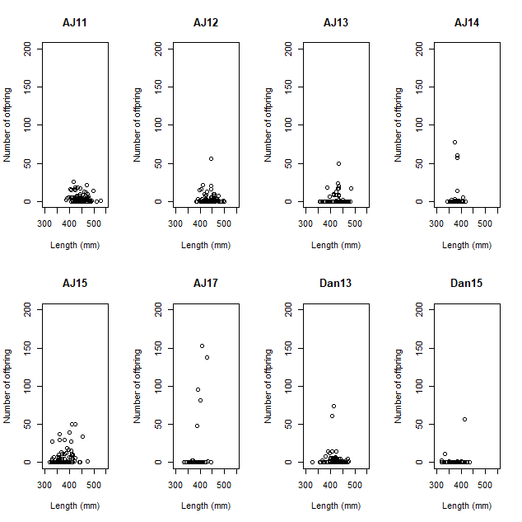
Figure 2.—Scatterplots of individual length against number of offspring for samples from AJ and DAN.

The number of adults contributing offspring and how many they produce may be influenced by factors like the timing and number of progeny sampled and age of progeny (e.g., larvae, juveniles) considered. Perhaps most significantly, variation in levels of mortality among years and locations will have a dramatic impact on the number and sex of adults that contribute offspring and their reproductive success (see below). This mortality is a significant factor that needs to be addressed in the design of refugial backwater populations.

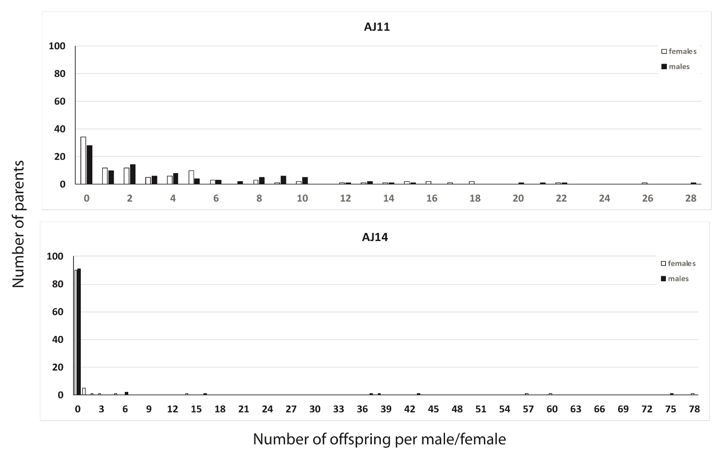
Figure 3.—Examples of reproductive success in RASU backwater populations. Number of offspring contributed by individual females and males are indicated by open and shaded bars, respectively.
Conditions in the ponds can be highly variable throughout the year, therefore, we also investigated survivorship of larvae to juveniles produced by specific males and females. Small sample sizes, empty cells and ties makes analysis of this data difficult; nevertheless, we used a Wilcoxon signed-rank test for heuristic purposes where males, females, and sexes combined for each sample were examined, considering only those individuals that had produced at least one offspring (table 16). For AJ, the rank distribution of juveniles was not significantly different from those of larvae (P > 0.05) for all female samples and progeny of males sampled in 2015 and 2017. When combined, all samples exhibited significant differences between ranked distributions of larvae and juveniles with the exception the AJ sample from 2017. For DAN, all comparisons were significant with the exception of male and female samples from 2015.

Significance of some but not all tests indicates that there is a difference in the contribution of adults to larvae and juveniles. This pattern could result from insufficient statistical power for some tests. For example, the larger number of significant tests for males than females may reflect greater impacts of increased male mortality in these ponds (see below). Significance of all combined tests except for AJ 2017 (a small sample) may reflect differential survival of larvae over summer months. Potential differences among the sexes may reflect variable conditions in these ponds from year to year and their influence on demographics of local backwater populations.

Table 16.—Test of difference of contribution of females, males, and both combined to larvae and juveniles for each ephemeral pond sample.
“*” identifies samples that were statistically significant using Wilcoxon signed-rank tests. V and P are the test statistic and P values.

 | female |  | male |  | combined
location | V | P | V | P | V | P
AJ 2011 | 1302.0 | 0.079 | 423.5 | 0.031* | 3207.5 | 0.005*
AJ 2012 | 43.0 | 0.571 | 37.0 | 0.002* | 162.0 | 0.004*
AJ 2013 | 38.0 | 0.073 | 79.5 | 0.018* | 219.5 | 0.003*
AJ 2014 | 15.0 | 0.059 | 21.0 | 0.036* | 66.0 | 0.004*
AJ 2015 | 303.0 | 0.283 | 469.5 | 0.076 | 1511.0 | 0.039*
AJ 2017 | 1.0 | 0.125 | 7.0 | 1.000 | 12.0 | 0.126
Dan 2010 | 45.0 | 0.009* | 55.0 | 0.006* | 190.0 | 0.000*
Dan 2013 | 29.0 | 0.008* | 3.5 | 0.000* | 68.0 | 0.000*
Dan 2015 | 3.0 | 0.371 | 10.0 | 0.097 | 21.0 | 0.035*

Yuma Backwater

YUMA was initially used as a grow out pond for RASU, with individuals stocked directly into the lake. Attempts were made to remove all RASU from the pond prior to start of this experiment; however, there may have been holdovers from the previous use. The experimental set up at YUMA was different because this backwater is permanent, and progeny of stocked adults were allowed to recruit into this pond. In addition, significant mortality in 2013 (especially of males) led to stocking of an additional 100 individuals (50 females and 50 males) in both 2014 and 2015 which also experienced high mortality (discussed in more detail later).

Remote sensing

In YUMA, losses observed through PIT scanning were high immediately after stocking in 2013, especially for males (figure 4). Nearly all RASU stocked in 2014 and 2015 were lost to PIT scanning within a few months; within three months of each stocking only one male and few females (five in 2014 and ten in 2015) were contacted. The majority of individuals contacted more than three months post-stocking regardless of stocking year continued to be contacted for the remainder of the study indicating survival of established adults was high. For example, approximately 80 females from the 2013 stocking were contacted after initial losses and more than 50 were contacted in 2019; 62.5% survival over six years equating to 92.4% average annual survival. RASU lost to PIT scanning includes tag loss, which was not estimated.

The capture of small (less than 350 mm TL) untagged RASU in YUMA within a year of initial stocking (2013) provided evidence of spawning and recruitment (table 17). Evidence of ongoing recruitment in subsequent years was provided by the continued capture of small untagged RASU, and the number of untagged RASU in each capture event outnumbered the recaptures in all capture events after 2014. However, the number of RASU tagged at capture in YUMA and
tracked by PIT scanners did not remain substantially greater than zero until the tagging event in May 2015 (figure 5). Subsequent tagging events continued to add to the total surviving potential recruits resulting in a sustainable population approaching 200 RASU. Most RASU that were PIT tagged in YUMA during the largest tagging event in October 2018 (498 individuals) were lost to PIT scanners within a couple months of being tagged. The losses may be due to overcrowding in YUMA as there may be over 400 RASU adults in the backwater, including PIT tagged and untagged recruits as well as surviving stocked RASU. The capture of large (565 mm TL) untagged RASU in the first November after initial stocking (table 17) indicates tag loss or that at least one RASU was not removed from YUMA prior to stocking in 2013.

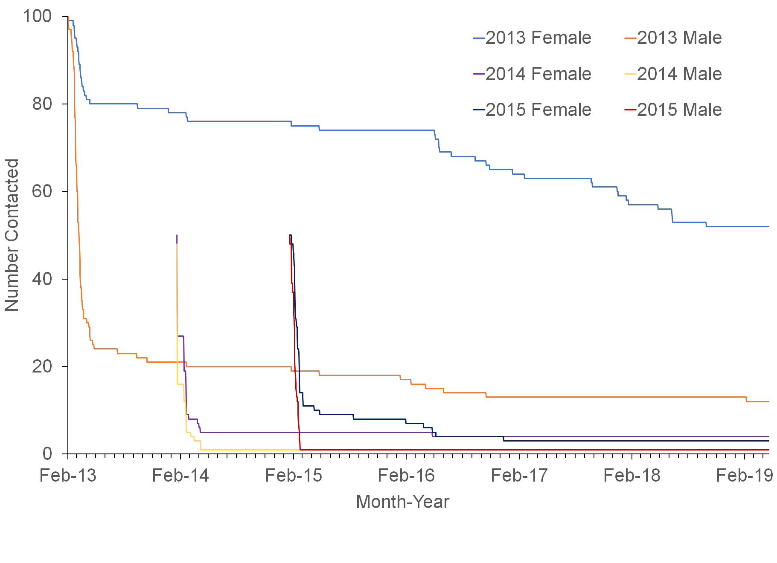
Figure 4.—PIT tagged and released RASU tracked in YUMA from February 2013 through March 2019.

Table 17. RASU captures from routine monitoring efforts in YUMA.
TL is in mm.
 |  |  | Males |  | Females |  | Unknown
Month - Year | Recap (N) | Recap (Y) | Captures | Mean TL (Range) | Captures | Mean TL (Range) | Captures | Mean TL (Range) | Total
Nov-13 | 57 | 80 | 4 | 454 (439-475) | 4 | 463 (416-495) | 129 | 441 (286-565) | 137
Jan-14 | 1 | 12 | 4 | 501 (482-515) | 4 | 529 (480-565) | 5 | 345 (330-360) | 13
May-14 | 0 | 74 | 11 | 488 (405-530) | 59 | 524 (430-565) | 4 | 427 (390-481) | 74
May-15 | 124 | 42 | 0 | - | 0 | - | 166 | 432 (354-585) | 166
May-16 | 56 | 44 | 27 | 446 (400-520) | 64 | 477 (380-600) | 9 | 444 (415-480) | 100
Oct-16 | 126 | 14 | 7 | 446 (430-476) | 1 | 585 (585-585) | 132 | 318 (227-586) | 140
May-17 | 10 | 9 | 11 | 470 (446-501) | 5 | 484 (446-557) | 3 | 274 (266-285) | 19
Oct-17 | 95 | 36 | 25 | 471 (365-610) | 35 | 526 (410-595) | 71 | 340 (255-495) | 131
Oct-18 | 498 | 24 | 12 | 458 (400-515) | 25 | 501 (390-596 | 485 | 177 (130-439) | 522
Nov-19 | 52 | 37 | 44 | 434 (330-535) | 42 | 510 (345-592) | 3 | 361 (340-386) | 89
Total | 1021 | 418 | 145 |  | 239 |  | 1007 |  | 1391

Of the original 200 RASU stocked into YUMA, 94 (75 females and 19 males) were known to be available during all three spawning seasons with parental assignment data; they were PIT scanned at least once after May 1, 2015. Out of that total, 86 (69 female and 17 male) were identified as the parents of at least one larvae or juvenile in those three years.. Broken down by year, 60 contributed in 2013 (48 females and 12 males), 65 in 2014 (53 females and 12 males), and 71 in 2015 (59 females and 12 males). Although 12 males contributed each year, they weren’t the same males; 7 males contributed in all three years along with 28 females. Estimates of reproductive contribution for RASU may be similar to BTC when correcting for mortality of breeders. This illustrates the need to take into this mortality into account when estimating reproductive success. Unfortunately, it is not possible to make such corrections for the ephemeral ponds as the long term perspective is not available to provide this estimate.

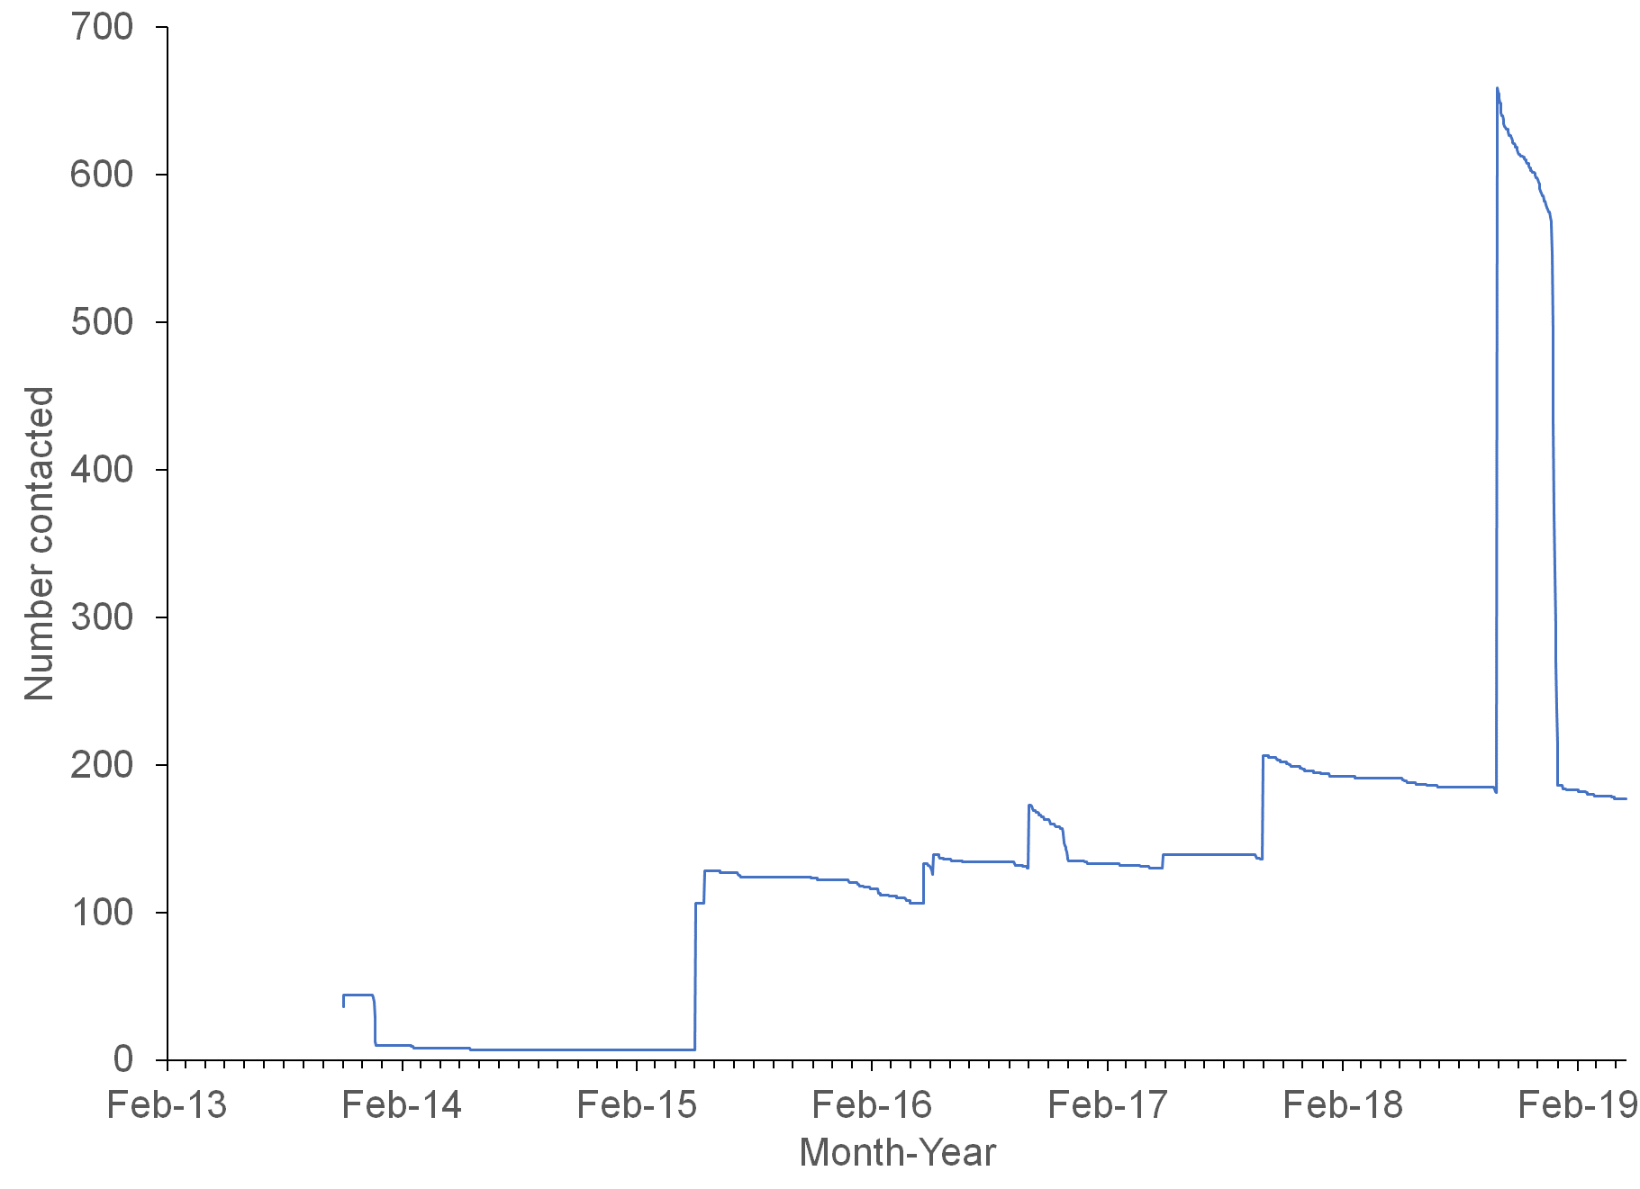
Figure 5.—Captured and PIT tagged RASU tracked in YUMA from February 2013 through March 2019.

Table 18. Data for RASU stocked in YUMA in 2013 for which offspring (larvae or juvenile) were collected in 2014 or 2015 and were not scanned after 2013.
Sex | TL at release (mm) | PIT | Last Contact | Offspring
2014
M | 377 | 1B796EEB8F | 10/24/2013 | 4
M | 408 | 1B796EDFDC | 7/20/2013 | 19
M | 414 | 1B796EE3DE | 3/21/2013 | 8
M | 396 | 1B796EE161 | 3/18/2013 | 34
M | 381 | 1B796ED7E8 | 3/11/2013 | 1
M | 393 | 1B796EEAE7 | 2/28/2013 | 6
F | 404 | 1B796EE4E6 | 3/21/2013 | 19
2015
F | 426 | 1B796EDEED | 4/5/2013 | 6
F | 395 | 1B796EE0B9 | 3/23/2013 | 4
F | 404 | 1B796EE4E6 | 3/21/2013 | 21
F | 400 | 1B796EFB70 | 3/16/2013 | 6
F | 353 | 1B796EE6EB | 2/27/2013 | 1
M | 408 | 1B796EDFDC | 7/20/2013 | 21
M | 414 | 1B796EE3DE | 3/21/2013 | 29
M | 396 | 1B796EE161 | 3/18/2013 | 32
M | 381 | 1B796ED7E8 | 3/11/2013 | 4
M | 405 | 1B796EEB36 | 3/4/2013 | 1
M | 393 | 1B796EEAE7 | 2/28/2013 | 37

Some offspring were assigned to parents that were not verified through PIT scanning. Seven larvae or juveniles collected in 2014 and 11 in 2015 were assigned to RASU stocked in 2013 that lacked PIT scanning records after 2013 (table 18). The majority of these adults were lost to PIT scanning within three months of stocking, and most had multiple offspring assigned to them indicating that the assignment was likely correct. Six of the seven from 2014 were also part of the 11 in 2015. It is unlikely that these six RASU evaded PIT scanners for more than two years while contributing to reproduction. Therefore, PIT tag loss or failure is the most likely cause.

Genetic characterization

Surviving stocked adults produced larvae annually that grew into juveniles (see cover photo), and these individuals likely contributed offspring in later years (hereafter “recruits”). Not all recruits could be captured and sampled, and reproduction of these individuals would likely confound parentage assignment, making it difficult to assess their contribution of offspring. Characterization of these samples with markers based on hundreds of SNPs will provide additional power to address this issue.

Proportional contribution of females and males from 2013 were comparable to each other and samples from AJ and DAN as 55.0% of stocked males and females contributed offspring, with 51.8% of these individuals being produced by uniques pairs of parents (see table 13). The proportional contribution of stocked adults declined in 2014 and 2015, especially in males (14.7% and 9.0% for 2014 and 2015, respectively) relative to females (36.7%% and 32.5% for 2014 and 2015, respectively). The fraction of offspring produced unique combinations of females and males also declined to 43.9% in 2014 and 40.1% in 2015. These declines reflect the high mortality in newly stocked fish in the latter two years.

As with AJ and DAN, there was a highly significant relationship between the number of mates an individual had and the number of offspring they produced for both males and females (see table 14). Comparison of this relationship between males and females by permutation testing failed to find differences between males and females for each sample; therefore, the sexes have similar numbers of offspring per number of mates.
Patterns of reproductive success for males and females from over time from YUMA exhibited similar variation to that observed in AJ and DAN (figure 6). The number of individuals not contributing progeny increases from 2013 to 2015, due to the addition of males and females in 2014 and 2015 that did not contribute progeny. The number of females and males contributing progeny is the same in 2013; however, proportionally fewer males contribute progeny in later years due to differential mortality between the sexes (see below). Number of offspring contributed by individuals exhibits a relatively even decline in 2013; however, there are two females that make large contributions, one contributing 31 and another 71. Patterns are similar for 2014 (see figure 4) and 2015 (not shown). This distribution is less even in later years due to the higher fraction of individuals (especially males) not contributing offspring, with individual males contributing more offspring (34 and 85 for 2014 and 2015, respectively).
Because YUMA is a permanent pond, it was possible to follow specific adults over time and to assess their reproductive contribution each year (figure 7). Of the 100 males stocked in 2013, 55 produced offspring in 2013, with 42 of these reproducing only in that year; only 17 and 16 of the original 100 males reproduced in 2014 and 2015, respectively. One individual spawned only in 2014, and none spawned only in 2015.
Seventeen males produced offspring in multiple years, with 11 reproducing in all three years and 5 reproducing in 2014 and 2015. Only one male skipped spawning, reproducing in 2013 and 2015; however, it may have spawned in 2014 but its progeny were not sampled. For the 17 individuals that spawned in multiple years, reproductive output increased over time, with mean # offspring increasing across the three years examined (mean # of offspring/individual: 2013 - 4.7; 2014 – 12.0, and 2015 - 23.3). Examination of the variance in reproductive success for individuals among years by GLMM was highly significant (ID = 1.69, SE = 0.31, z-score = 5.42, P < 0.0001). Therefore, high mortality likely reduced the number of spawning males after 2013; however, those that survived contributed more progeny. This could reflect increased fecundity with age; however, it is not possible to separate this result from their increased probability of contributing due to the smaller number of males in later years.

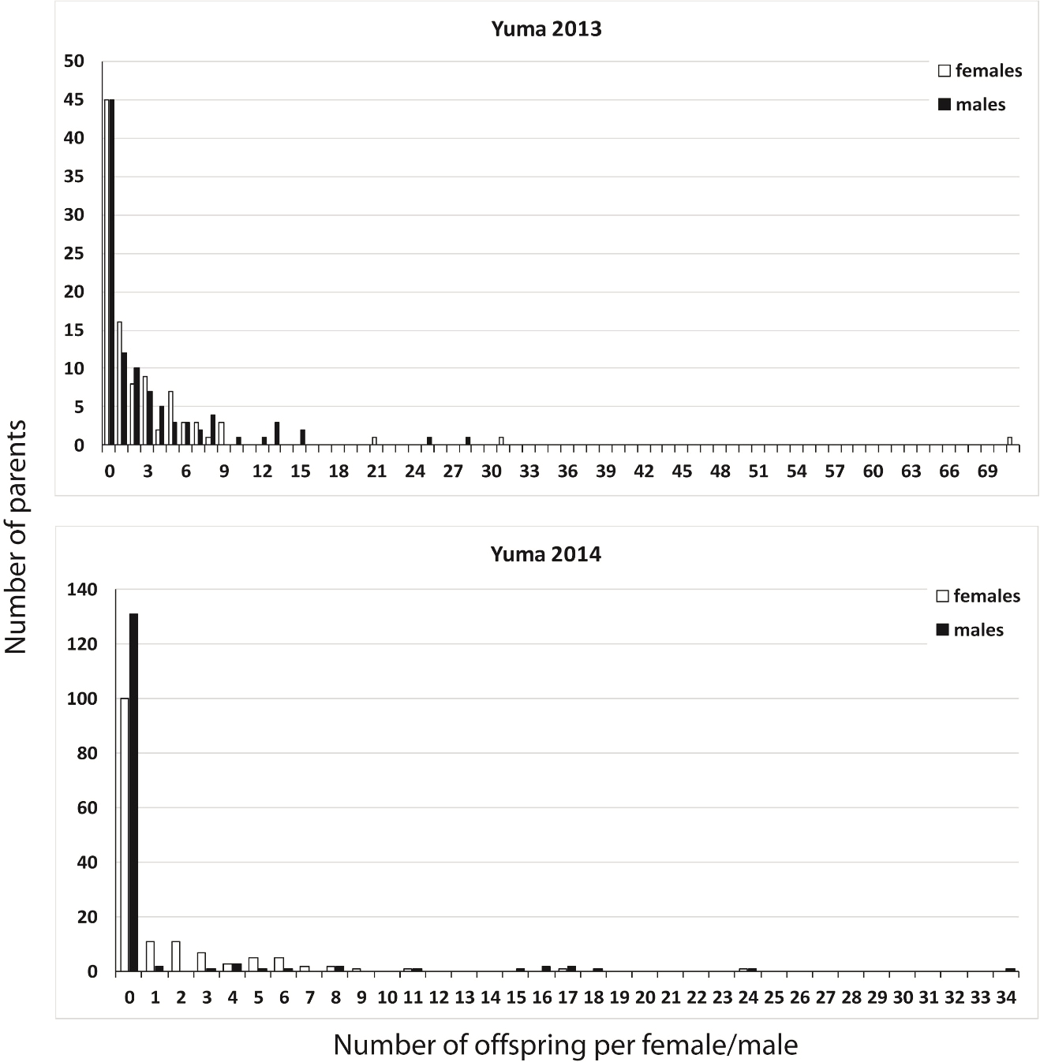
Figure 6.—Patterns of reproductive success for females and males from YUMA 2013 and 2014.
Number of offspring contributed by individual females and males are indicated by open and shaded bars, respectively.

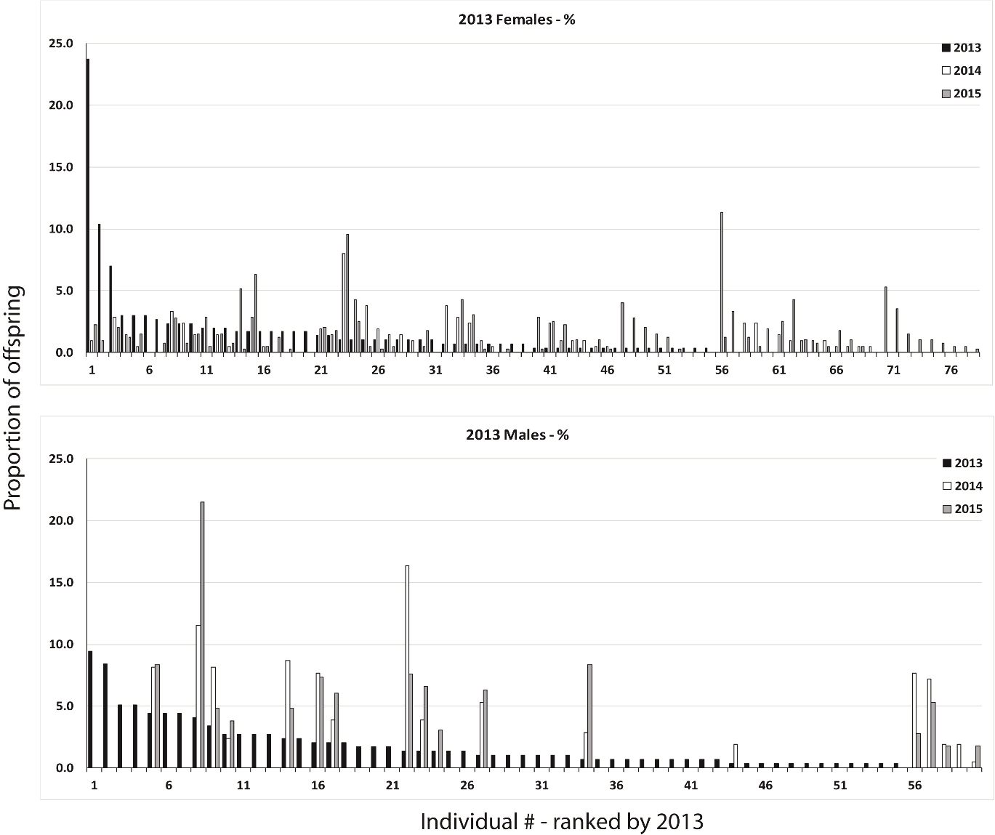
Figure 7.—Proportional contribution of individual females (top panel) and males (bottom panel) from YUMA 2013 for all three years (2013 – 2015).
Each bar represents the percentage of offspring attributable specific individuals for all three years, with individual samples on the x-axis ranked by number of offspring they contributed in 2013.
Females persisted longer in YUMA and reproduced more often. Of the 100 females stocked in 2013, 55 produced offspring in 2013, while 50 and 60 reproduced in 2014 and 2015, respectively. Of these females, 9, 3, and 9 fish produced only in the years 2013, 2014, and 2015, respectively. Fifty-seven females produced offspring in multiple years, with 11 reproducing in all three years and 5 reproducing in 2014 and 2015. Ten females skipped spawning, reproducing in 2013 and 2015. They may have spawned in 2014 and their progeny were not sampled but that seems unlikely for so many individuals. For the 57 females that spawned in multiple years, reproductive output was significantly different across years (mean # of offspring/individual: 2013 – 4.7; 2014 – 3.5, and 2015 – 5.9) as indicated by GLMM (ID = 0.69, SE = 0.14, z-score = 5.12, P < 0.0001). Therefore, reproductive contribution of individual females varied among years (figure 7), with individuals that produced many offspring in some years producing few in others. This variation could be real, with reproductive effort varying among years or may be an artifact due to sampling or differential survival. Understanding variation in reproductive success is critical as this leads to the contribution of progeny by more individuals over time, resulting in increased levels of genetic variation relative to situations where reproductive contribution of individuals was less variable.

Imperial Ponds

Post-stocking trends in RASU PIT scanning in all three IP ponds (IP1, IP3, and IP4) were similar to the trend in YUMA (figure 8). Immediate losses were disparate between the sexes with more males lost to PIT scanners than females. Initial post-stocking losses for both sexes were proportionally fewer than for losses at YUMA; 90% of stocked females were contacted more than two months after release and 60% of males in IP ponds whereas YUMA had fewer than 80% of females and 30% of males.

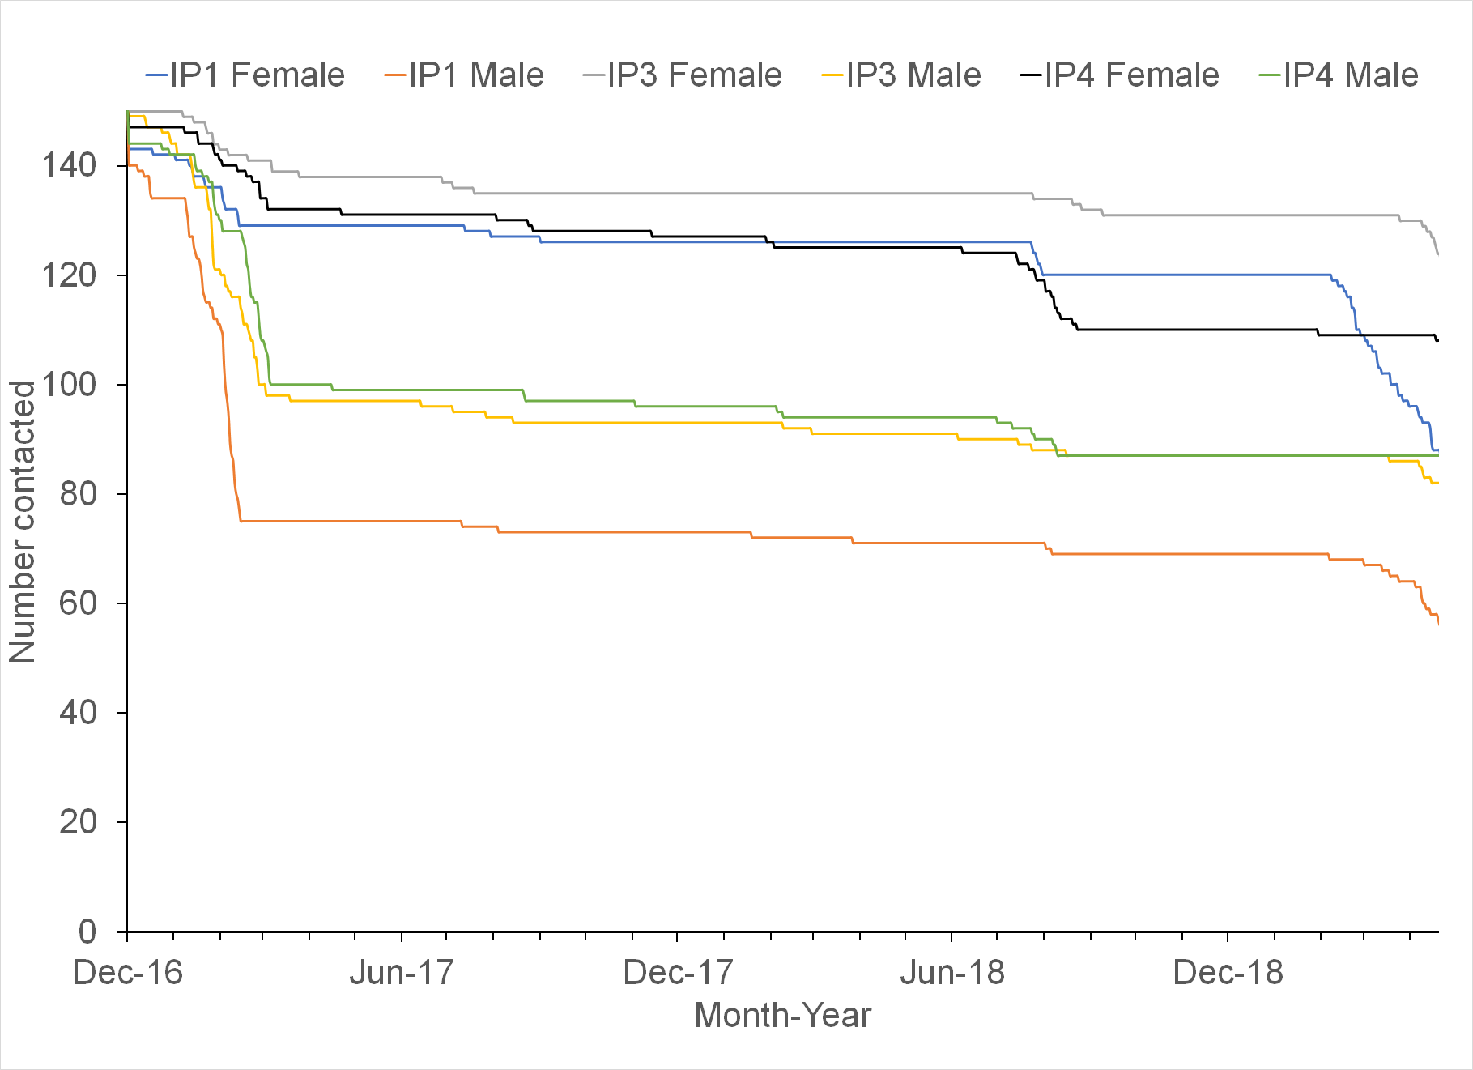
Figure 8.—PIT tagged and released RASU tracked in three ponds at Imperial National Wildlife Refuge from December 2016 through April 2019.

Literature Cited

Burgad, A. A., J. J. Rennert, B. R. Kesner, C. A. Pacey, and P. C. Marsh. 2019. Demographics and monitoring of repatriated razorback suckers in Lake Mohave, 2018 annual report submitted to the Lower Colorado River Multi-Species Conservation Program, Bureau of Reclamation, Boulder City, Nevada, by Marsh & Associates, LLC, Tempe, Arizona, under contract No. R15PD00130.
Carson, E. W., T. F. Turner, M. J. Saltzgiver, D. Adams, B. R. Kesner, P. C. Marsh, T. J. Pilger, and T. E. Dowling. 2016. Retention of ancestral genetic variation across life-stages of an endangered, long-lived iteroparous fish. Journal of Heredity 107:567-572.
Dowling, T. E., B. R. Kesner, P. C. Marsh, and T. F. Turner. 2017. Genetic and demographic studies to guide conservation management of razorback sucker in off-channel habitats: 2010 - 2015 Annual Report. Annual report submitted to the U. S. Bureau of Reclamation, Boulder City, Nevada. 42 p.
Dowling, T. E., W. L. Minckley, P. C. Marsh, and E. Goldstein. 1996a. Mitochondrial DNA diversity in the endangered razorback sucker (Xyrauchen texanus): analysis of hatchery stocks and implications for captive propagation. Conservation Biology 10:120-127.
Dowling, T. E., W. L. Minckley, and P. C. Marsh. 1996b. Mitochondrial DNA diversity within and among populations of razorback sucker (Xyrauchen texanus) as determined by restriction endonuclease analysis. Copeia 1996:542-550.
Dowling, T. E., P. C. Marsh, A. T. Kelsen, and C. A. Tibbets. 2005. Genetic monitoring of wild and repatriated populations of endangered razorback sucker (Xyrauchen texanus, Catostomidae, Teleostei) in Lake Mohave, Arizona-Nevada. Molecular Ecology 14:123-135.
Dowling, T. E., T. F. Turner, E. W. Carson, M. J. Saltzgiver, D. Adams, B. Kesner, and P. C. Marsh. 2014. Genetic and demographic responses to intensive management of razorback sucker in Lake Mohave, Arizona-Nevada. Evolutionary Applications 7:339-354.
Ehlo, C. A., M. J. Saltzgiver, T. E. Dowling,, P. C. Marsh, P. C., and B. R. Kesner. 2017. Use of molecular techniques to confirm nonnative fish predation on razorback sucker larvae in Lake Mohave, Arizona and Nevada. Transactions of the American Fisheries Society 146:201-205.
Garrigan, D., P. C. Marsh, and T. E. Dowling. 2002. Long-term effective population size of endangered Colorado River fishes. Animal Conservation 5:95-102.
Goudet, J. 2001. FSTAT, a program to estimate and test gene diversities and fixation indices (version 2.9.3). Available from http://www.unil.ch/izea/softwares/fstat.html.
Heck, K. L. Jr., G. van Belle, and D. Simberloff. 1975. Explicit Calculation of the Rarefaction Diversity Measurement and the Determination of Sufficient Sample Size. Ecology 56:1459-1461.
Jones, O. and J. Wang. 2010. COLONY: a program for parentage and sibship inference from multilocus genotype data. Molecular Ecology Resources 10:551–555.
Ley, G., M. J. Saltzgiver, T. E. Dowling, A. P. Karam, B. R. Kesner, and P. C. Marsh. 2014. Use of a molecular assay to detect predation on an endangered fish species. Transactions of the American Fisheries Society 143:49-54.
Kesner, B. R., G. Ley, M. K. Fell, and P. C. Marsh. 2008. Imperial Ponds Native Fish Research Final Project Report October 2007 - June 2008. USBR Agreement Number 08FG300001, Boulder City, Nevada. Arizona State University, Tempe. 29 pages.
Knudson, C. 2018. glmm: Generalized linear mixed models via Monte Carlo likelihood approximation. R package version 1.3.0. https://CRAN.R-project.org/package=glmm
Marsh, P. C. and D R. Langhorst. 1988. Feeding and fate of wild larval razorback sucker. Environmental Biology of Fishes 21:59-67.
Marsh, P. C., T. E. Dowling, B. R. Kesner, T. F. Turner, and W. L. Minckley. 2015. Conservation to stem imminent extinction: the fight to save razorback sucker Xyrauchen texanus in Lake Mohave and its implications for species recovery. Copeia 103:141-156.
Marsh, P.C., B. R. Kesner, and C.A. Pacey. 2005. Repatriation as a management strategy to conserve a critically imperiled species. North American Journal of Fisheries Management 25: 547-556.
Marsh, P.C., C.A. Pacey and B.R. Kesner. 2003. Decline of the razorback sucker in Lake Mohave, Colorado River, Arizona and Nevada. Transactions of the American Fisheries Society 132:1251-1256.
McCarthy, M. S. and W. L. Minckley. 1987. Age estimation for razorback sucker (Pisces: Catostomidae) from Lake Mohave, Arizona and Nevada. Journal of the Arizona-Nevada Academy of Science 21:87–97.
Minckley, W. L. 1983. Status of the razorback sucker, Xyrauchen texanus (Abbott), in the Lower Colorado River Basin. Southwestern Naturalist 28:165-187.
Minckley, W.L. and P.C. Marsh. 2009. Inland Fishes of the Greater Southwest: Chronicle of a Vanishing Biota. The University of Arizona Press, Tucson.
Minckley, W. L., P. C. Marsh, J. E. Deacon, T. E. Dowling, P. W. Hedrick, W. J. Matthews, and G. Mueller. 2003. A conservation plan for lower Colorado River native fishes. BioScience 53:219-234.
Narum, S. R. 2006. Beyond Bonferroni: Less conservative analyses for conservation genetics. Conservation Genetics 7:783-787.
Osborne, M. J. A. V. Sanchez, T. E. Dowling, and T. F. Turner. 2018. Variance in reproductive success is driven by environmental factors, not mating system, in Bonytails. Transactions of the American Fisheries Society 147:1100-1114.
R Core Team. 2019. R: A language and environment for statistical computing. R Foundation for Statistical Computing, Vienna, Austria. URL https://www.R-project.org/.
Schooley J.D., A.P. Karam, B.R. Kesner, P.C. Marsh, C.A. Pacey, and D.J. Thornbrugh. 2008. Detection of larval remains after consumption by fishes. Transactions of the American Fisheries Society 137:1044-1049.
Tibbets, C. A., and T. E. Dowling. 1996. Effects of intrinsic and extrinsic factors on population fragmentation in three North American minnows (Teleostei: Cyprinidae). Evolution 50:1280-1292.
Turner, T. F., T. E. Dowling, P. C. Marsh, B. R. Kesner, and A. T. Kelsen. 2007. Effective size, census size, and genetic monitoring of the endangered razorback sucker, Xyrauchen texanus. Conservation Genetics 8:417-425.
Turner, T. F., T. E. Dowling, M. J. Osborne, M. V. McPhee, R. E. Broughton, and J. R. Gold. 2009. Microsatellite markers for the endangered razorback sucker, Xyrauchen texanus, are widely applicable to genetic studies of other catostomine fishes. Conservation Genetics 10:551-553.
USFWS. 1991. Endangered and threatened wildlife and plants; the razorback sucker (Xyrauchen texanus) determined to be an endangered species. Federal Register 56(205):54957-54967.
Waples R. S. Waples, K. T. Scribner, J. A. Moore, H. M. Draheim, D. Etter, and M. Boersen. 2018. Accounting for age structure and spatial structure in eco-evolutionary analyses of a large, mobile vertebrate. Journal of Heredity 109:709-723.

The berm in AJ was compromised in June and most RASU escaped from the backwater, none were harvested.
The berm in AJ was compromised in the summer, harvest numbers are from netting efforts in May 2018 prior to berm breach.

